POSITIVE PARTNERSHIPS · PROFESSIONAL LEARNING
Facilitator Guide
Primary Education Online
SESSION  1 | SESSION  2 | SESSION  3 | SESSION  4

One page for every slide. Each page shows the slide, what it is for, what to do and say, the activity and how long to spend.
Four online sessions of 60 minutes · Timings are indicative

How to use this guide
The guide follows the four online slide decks exactly. Every visible slide has its own page, in deck order, so you can keep the guide open beside the presenter view and turn one page per slide.
Each session opens with a planning page: the intent, what participants will leave with, what to prepare, and a run sheet. Times are minutes into the 60-minute session. A producer cue page follows, listing each activity, how it runs and what to paste in the chat.
EVERY SLIDE PAGE HAS
Header strip | The session colour, the session name and the slide number in the deck.
Slide and facts | A picture of the slide, the suggested minutes, the minutes into the session, the grouping, and the Participant Guide page if there is one.
Purpose | One line on why the slide is there.
What to do | Numbered steps, in order.
Key messages | What participants should take from the slide.
You might say | Wording you can use or adapt, where the team has written it.
Activity card | Format, grouping, time, the prompt, steps, how to bring the room back and how to close.
Keep in mind | Cautions and what to avoid.
Background and thread | Context for you, and how the slide links to other sessions.

SESSION COLOURS
Each session keeps the colour used in the Participant Guide, so the page a participant has open matches the colour on your page.

The series at a glance
Length | Session |  | Slides | Page
60 minutes | 1 | Lens and Autistic Experience | 18 slides | p. 6
60 minutes | 2 | Communication, Connection and the Primary School Day | 16 slides | p. 26
60 minutes | 3 | Designing for Access in the Primary Classroom | 16 slides | p. 44
60 minutes | 4 | Partnership, Flourishing and Next Steps | 16 slides | p. 62

The thread through the series
Participants hold two or three real, different students in mind from Online Session 1 onwards. The sessions run on separate days, so each one opens by reconnecting with the last. Several Participant Guide pages carry forward:
- Online Session 1: Think about your students and the routine review, plus a noticing task before Session 2.
- Online Session 2: the school-day map and the Carry into design card (brought to Session 3).
- Online Session 3: the brief, the design and the private My students check.
- Online Session 4: Bridge to the next family conversation, Start · Continue · Reconsider, the conversation plan and the final reflection back to Session 1.

Ways of working
- Cameras are optional. Chat, reactions, speaking, private notes or passing all count as taking part.
- Invite contributions; never cold-call. Put every activity prompt in the chat before breakout rooms open.
- Keep the students participants have in mind anonymous. Initials or roles only, in the chat and in breakout rooms.
- Breakout rooms are pairs or trios. Anyone can ask to stay in the main room, with a main-room option for each activity.
- Work with a producer or co-host who admits participants, opens breakout rooms, and pastes prompts and links into the chat.
- Look at the environment, task and routine before asking a student to change. Include strengths, interests and joy.
- Participants write in their Participant Guide (digital or printed).

Before each session
☐ Deck open in presenter view, with videos tested with shared sound and captions.
☐ Producer or co-host confirmed, with the prompts and links for this session ready to paste into the chat.
☐ Participant Guide link sent to participants, with a note to have it open or printed.
☐ Breakout rooms planned (pairs or trios) and the main-room option agreed.
☐ The session Prepare list checked. Each session opens with its own list, on its planning page.

Running it online
Roles
- Facilitator: leads the content and the room, and keeps an eye on time.
- Producer or co-host: admits people, runs breakout rooms, pastes prompts and links into the chat, watches the chat, and helps anyone with technical problems by private message.
- Agree before each session who takes over if the facilitator loses connection. The producer keeps the room going (for example by starting the next discussion in the chat) until the facilitator is back.

Zoom settings
- Turn on automatic captions (live transcription) at the start of each session and tell participants how to show them.
- Breakout rooms: allow participants to return to the main room, set a 60-second countdown, and assign manually or automatically as suits the group. Keep a note of anyone who asked to stay in the main room.
- Share sound when playing videos. Have the video link ready to paste in the chat in case playback stutters.
- Whiteboard and annotation: check they are enabled for participants before the session that uses them.

Recording
- Decide before the series whether the main room is recorded, and tell participants at the start of each session.
- Never record breakout rooms. Remind people to use initials or roles only when talking about students.

If something goes wrong
- A video will not play: paste the link in the chat, give people 2 or 3 minutes to watch, and move on to the discussion.
- Breakout rooms fail or people get lost: run the activity in the main room, with chat responses.
- Someone is distressed: the producer checks in by private message, and the facilitator follows up after the session.
- Running behind: each session names one or two places to shorten, on its first slide page.

SESSION  1 | ONLINE · 60 MINUTES · 18 SLIDES  Lens and Autistic Experience

SESSION INTENT
Welcome participants to the online series, centre student voice and establish a neurodiversity-affirming, environment-first lens. Participants bring two or three different students to mind and build a concise set of sensory, thinking and capacity concepts they can use to ask better questions about one familiar primary school routine.
PARTICIPANTS LEAVE WITH
- Hold two or three different students in mind as a reference point for the series.
- Describe a neurodiversity-affirming, environment-first lens and the idea of dynamic disability.
- Name the eight senses, sensory joy and stimming, detail-first processing, deep focus and executive functioning as lenses for inquiry.
- Look at the sensory and task demands of one familiar primary routine before the student's response.

RUN SHEET
Minutes in | Segment | Slides | Minutes
0 - 7 | Welcome, acknowledgements and taking part online | 1-4 | 7
7 - 22 | Students in mind and student voice | 5-7 | 15
22 - 32 | The lens: affirming stance, social model, dynamic disability | 8-10 | 10
32 - 37 | Sensory processing | 11-12 | 5
37 - 47 | Autistic thinking and internal signals | 13-16 | 10
47 - 58 | Sensory activity | 17 | 11
58 - 60 | Before the next session and close | 18 | 2

PREPARE
☐ Traditional Custodians confirmed for where you are presenting from, and Acknowledgement of Country prepared in your own words.
☐ Student voice video tested through screen share with sound and captions on; transcript link ready.
☐ Chat and reactions enabled; breakout rooms set for 2 or 3 per room.
☐ Producer or co-host briefed: admitting late joiners, pasting prompts and links, opening breakouts.
☐ Activity prompt and between-session prompts ready to paste into the chat.
☐ Participant Guide sent in advance so people have a digital or printed copy.
☐ Visible timer and a main-room alternative ready for the activity.

Producer cues · Session 1
For the producer or co-host. At the start: admit participants, turn on captions, and paste the Participant Guide link and the session title in the chat. For each activity: paste the prompt before rooms open, broadcast a one-minute warning, and close rooms on time.
Slide | Activity | How | Time | Paste in the chat
5 | Think about your students | on your own | 3 minutes | What are you here for? What would you like to understand better? What strengths, interests or moments of connection should stay visible?
7 | What did you notice? | on your own, then the chat | 4 minutes | What did you notice? What stayed with you? What would you like to understand more deeply?
17 | Sensory activity | breakout rooms of 2 or 3, with a main-room option | 11 minutes (1 minute to choose, 6 minutes in breakout rooms plus 1 minute for rooms to open and close, 3 minutes to debrief) | Choose one familiar classroom routine. What sensory demands does the environment or task create, and what options could increase access or choice?

SESSION 1 | Lens and Autistic Experience | SLIDE 1 of 18

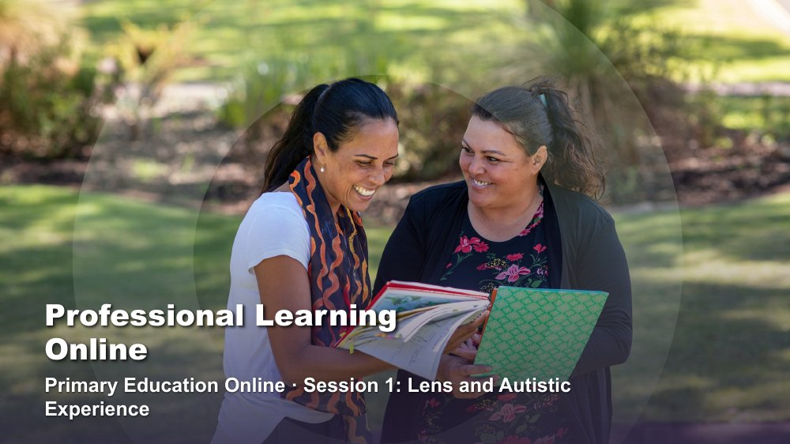 | Professional Learning Online - Primary Education  SUGGESTED TIME  1 min  MINUTES INTO SESSION  0 - 1

Open the online series with the shared starting point: how educators understand students and school.
WHAT TO DO  - Have the title slide shared as participants join; the producer can paste a short welcome in the chat.  - Welcome participants and introduce the delivery team, including the producer or co-host.  - Name this as professional learning about understanding Autistic experience and improving access, belonging and partnership.  - Frame the series around curiosity and support, not fixing students or making them appear less Autistic.  - Keep this opening brief so the student reflection and student voice keep their time. | KEY MESSAGES  - The series begins with the lens educators bring to students and school.  - Curiosity will connect the four online sessions.

KEEP IN MIND
- Late joiners are common online. The producer can admit them and paste the welcome again without the facilitator stopping.
- If running behind: keep Executive Functioning (slide 15) brief, since Session 3 (slide 6) covers executive functioning supports, and take a single share after the Sensory activity (slide 17).

SESSION 1 | Lens and Autistic Experience | SLIDE 2 of 18

 | Acknowledgement of Country  SUGGESTED TIME  2 min  MINUTES INTO SESSION  1 - 3

Acknowledge the Traditional Custodians of the land on which the session is taking place, including the many Countries participants are joining from.
WHAT TO DO
- Deliver the Acknowledgement of Country in your own words, following organisational protocol.
- Name the Traditional Custodians of the land you are presenting from, where this has been confirmed.
- Acknowledge that participants are joining from many Countries, and invite them to name the Country they are on in the chat if they wish.
- Allow a brief pause before moving on.

KEEP IN MIND
- Do not read a generic script you have not prepared; take time before the session to learn the Country and custodians where you are presenting from.
- Keep the Acknowledgement respectful and unhurried, even if the session is running late.

SESSION 1 | Lens and Autistic Experience | SLIDE 3 of 18

 | First Nations advisory  SUGGESTED TIME  1 min  MINUTES INTO SESSION  3 - 4

Advise First Nations participants that the session may contain images and voices of people who are no longer with us.
WHAT TO DO
- Read the advisory aloud, for anyone listening without video, and leave it on screen long enough for everyone to read it.
- Move on without further comment.

SESSION 1 | Lens and Autistic Experience | SLIDE 4 of 18

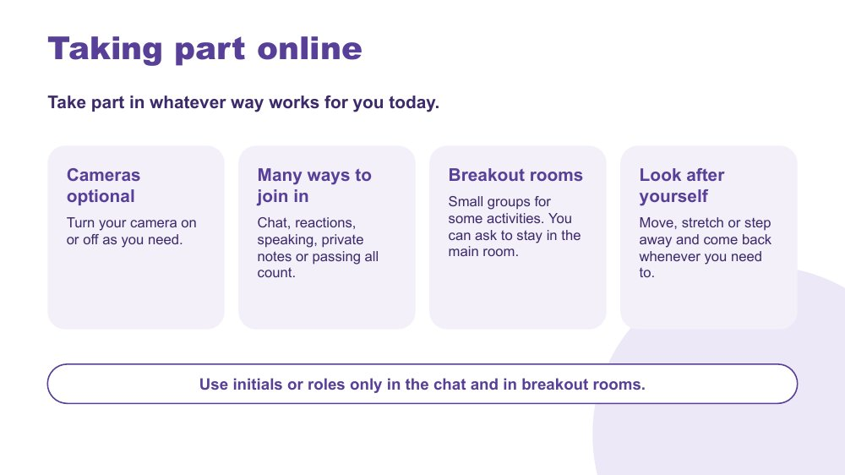 | Taking part online  SUGGESTED TIME  3 min  MINUTES INTO SESSION  4 - 7

Agree how people can take part online so every way of joining in counts, and set privacy expectations for the series.
WHAT TO DO  - Walk through the four points on the slide.  - Say that cameras are optional and people can turn them on or off as they need through the session.  - Name the ways to join in: chat, reactions, speaking, private notes or passing. All of them count.  - Explain that some activities use breakout rooms, and anyone can ask the producer to stay in the main room instead.  - Invite people to move, stretch or step away and come back whenever they need to.  - Ask everyone to use initials or roles only in the chat and in breakout rooms.  - Invite a quick first response: a reaction, or one word in the chat about what they are hoping for today. Passing is fine. | KEY MESSAGES  - Different ways of taking part online are welcome.  - Initials or roles only protects students and families.  - People can look after themselves at any point.

YOU MIGHT SAY
There is no single right way to take part today. Some people think best with their camera off, some by typing, some by listening. All of it counts.
When we talk about students, please use initials or a role, like 'a Year 2 student', rather than names.

KEEP IN MIND
- Do not cold-call. Invite, and let people choose how to respond.
- Breakout rooms are not recorded. If the main room is recorded, say so now and say what is captured.

Background The same things participants will be asked to offer students (choice, more than one way to communicate, permission to step away) are modelled here in how the session runs.
RESOURCES
- Zoom chat and reactions

SESSION 1 | Lens and Autistic Experience | SLIDE 5 of 18

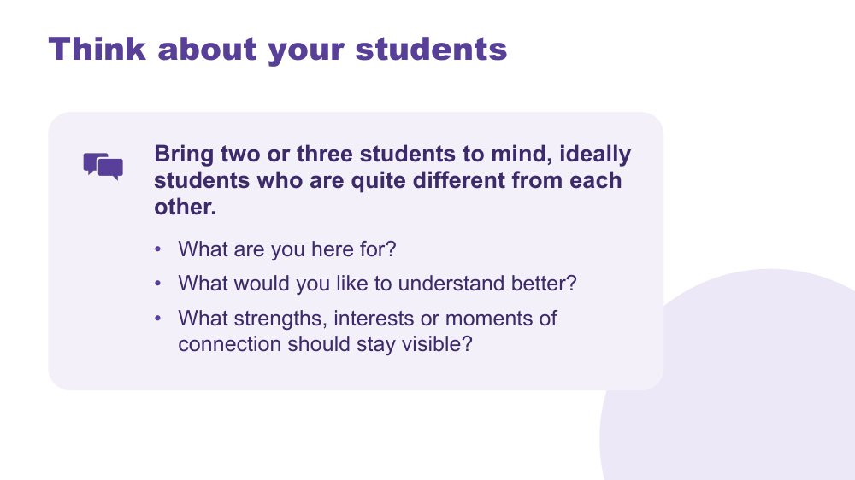 | Think about your students  SUGGESTED TIME  4 min  MINUTES INTO SESSION  7 - 11  GROUPING  On your own  PARTICIPANT GUIDE  Participant Guide - Think about your students

Give every participant a student-centred point of reference for the series.
WHAT TO DO  - Invite participants to bring two or three students to mind, ideally students who are quite different from each other.  - Suggest they might differ in age, communication or what school feels like for them.  - Ask participants to write in their Participant Guide or private notes, using initials or roles only. Not in the chat.  - Use the questions on screen to support private reflection.  - Give quiet thinking time; cameras can go off if that helps people think.  - If anyone shares, redirect descriptions away from labels and towards what they want to understand.  - Ask participants to return to the same students in each online session. | KEY MESSAGES  - See each student as a whole person, with strengths and interests as well as needs.  - Holding several different students builds a broad, mixed picture of Autistic experience.  - Questions can remain open while participants gather a fuller picture.

ACTIVITY | Private reflection on your own · 3 minutes
What are you here for? What would you like to understand better? What strengths, interests or moments of connection should stay visible?
- Ask participants to write without using students' names or school.
- Invite them to include strengths, interests or moments of connection as well as questions.
- Keep sharing optional; this reflection stays private.
Close: Ask participants to keep the reflection handy for the rest of the series.

Thread The students brought to mind here return in the school-day mapping (Online Session 2), classroom design (Online Session 3) and final reflection (Online Session 4).

SESSION 1 | Lens and Autistic Experience | SLIDE 6 of 18

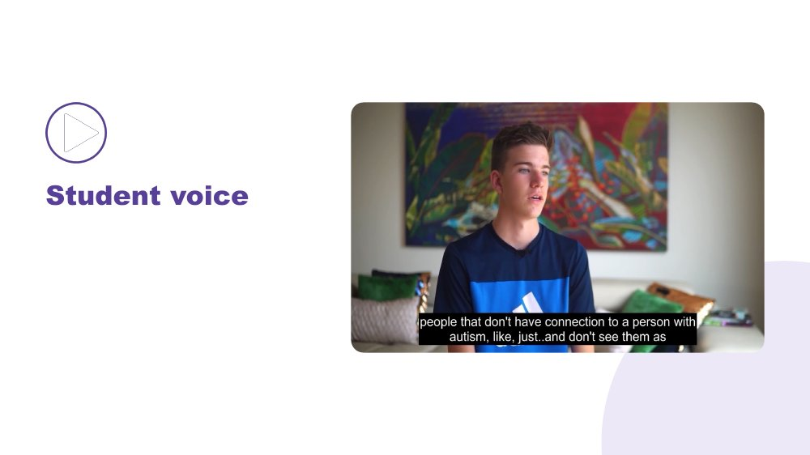 | Student voice  SUGGESTED TIME  6 min  MINUTES INTO SESSION  11 - 17

Make space for Autistic young people to be heard in their own words.
WHAT TO DO  - Introduce the video as an opportunity to listen rather than diagnose, compare or extract a single lesson.  - Share the video through Zoom screen share with computer sound on, and captions on.  - Producer pastes the transcript link in the chat.  - Play the video without interrupting. | KEY MESSAGES  - Student voice is part of the evidence in this series.  - Each speaker's account is their own.

KEEP IN MIND
- Test sound and playback through screen share before the session. If it stutters, have the producer share it, or paste a link so people can watch on their own device.

SESSION 1 | Lens and Autistic Experience | SLIDE 7 of 18

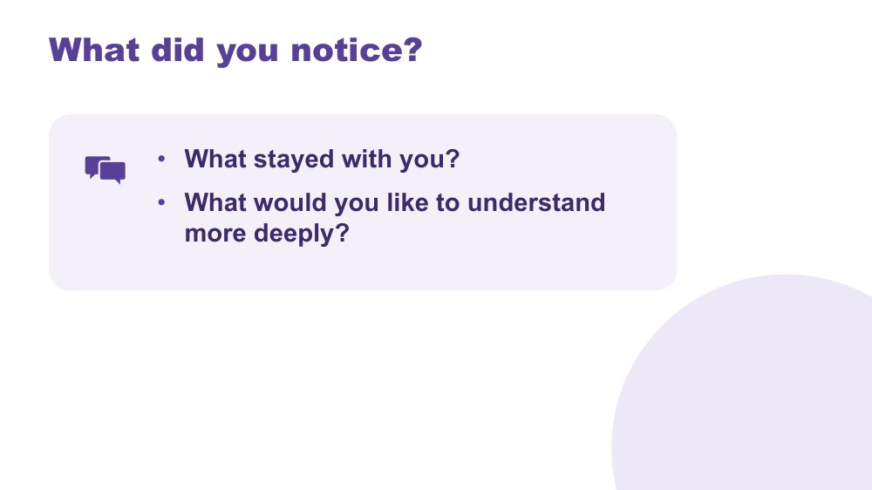 | What did you notice?  SUGGESTED TIME  5 min  MINUTES INTO SESSION  17 - 22  GROUPING  On your own, then the chat  PARTICIPANT GUIDE  Participant Guide - What did you notice?

Support reflection on the student voice material.
WHAT TO DO
- Invite brief private reflection on the questions before anyone responds.
- Invite observations grounded in what speakers said rather than interpretations of appearance or behaviour.
- Avoid asking participants to compare a speaker with a student they teach.
- Read out a few recurring words or questions from the chat without forcing consensus.
- Note questions that need follow-up through the appropriate program or local channel.

ACTIVITY | Think, write and optional share on your own, then the chat · 4 minutes
What did you notice? What stayed with you? What would you like to understand more deeply?
- Give a minute of quiet writing time.
- Invite one word or short phrase in the chat, or a spoken contribution. Passing is fine.
- Read out a few recurring words or questions so everyone can hear them.
Close: Link participants' questions to the sensory and thinking content that follows, and to communication and the school day in Online Session 2.

SESSION 1 | Lens and Autistic Experience | SLIDE 8 of 18

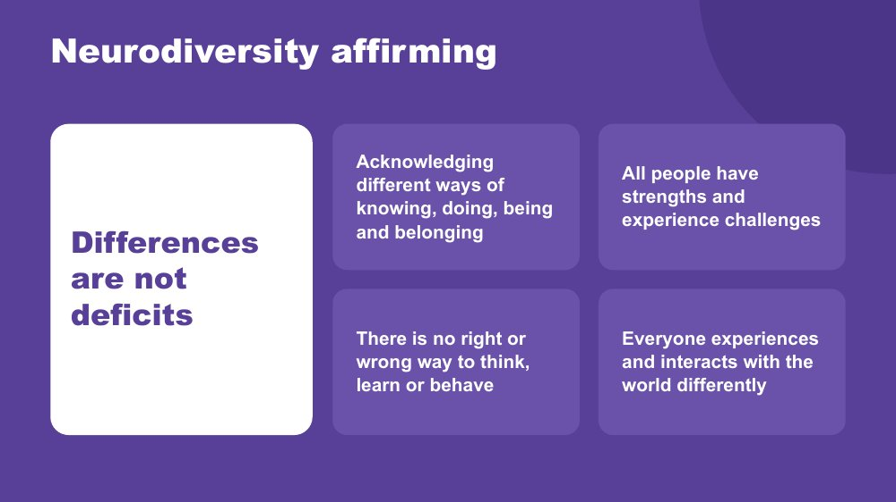 | Neurodiversity affirming  SUGGESTED TIME  4 min  MINUTES INTO SESSION  22 - 26

Establish the practical, strengths-based stance participants will use throughout the series.
WHAT TO DO  - Walk through the principles on the slide.  - Connect the principles to the students participants brought to mind earlier.  - Ask what becomes visible when strengths, interests, joy and ways of connecting are included. Invite a response in the chat or aloud.  - Clarify that a strengths-based approach does not erase difficulty, access needs or fluctuating capacity.  - Model language that describes the environment and support needed without blaming the student. | KEY MESSAGES  - Begin with the person.  - Include strengths and joy alongside barriers and support needs.  - Stay curious about access and support.

SESSION 1 | Lens and Autistic Experience | SLIDE 9 of 18

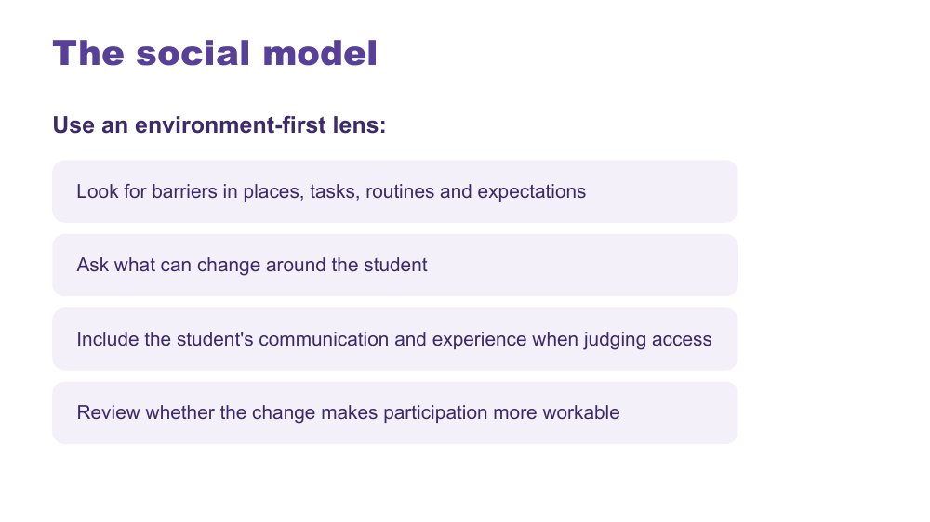 | The social model  SUGGESTED TIME  3 min  MINUTES INTO SESSION  26 - 29

Connect the series lens with an environment-first view of barriers.
WHAT TO DO  - Explain the social model through barriers in places, tasks, routines and expectations.  - Walk through the environment-first steps on the slide.  - Use one brief primary example, such as waiting in a noisy lunch line, and ask what could change around the student.  - Emphasise including the student's communication and experience when judging access. | KEY MESSAGES  - Look for barriers before asking the student to change.  - Environment and support are part of the experience being examined.

KEEP IN MIND
- Avoid implying that all difficulty disappears when an environment changes.

SESSION 1 | Lens and Autistic Experience | SLIDE 10 of 18

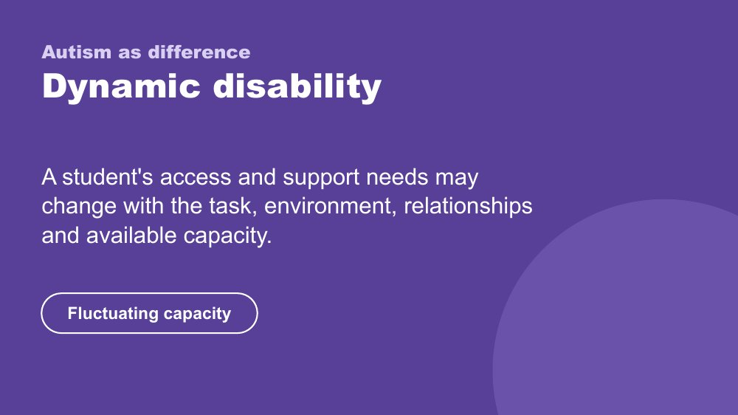 | Autism as difference - dynamic disability  SUGGESTED TIME  3 min  MINUTES INTO SESSION  29 - 32

Introduce the framing of autism as difference and dynamic disability.
WHAT TO DO  - Explain how access and support needs can vary with the task, environment, relationships and available capacity.  - Name fluctuating capacity: what a student can do one day or in one setting may not be available in another.  - Connect the concept back to the need for curiosity across settings and days. | KEY MESSAGES  - Support should respond to the student and context rather than a fixed assumption.  - Strengths and substantial support needs can both belong in the picture.

KEEP IN MIND
- Avoid presenting one pattern of ability, need or capacity as universal.
- Do not add clinical, diagnostic or legal claims.

SESSION 1 | Lens and Autistic Experience | SLIDE 11 of 18

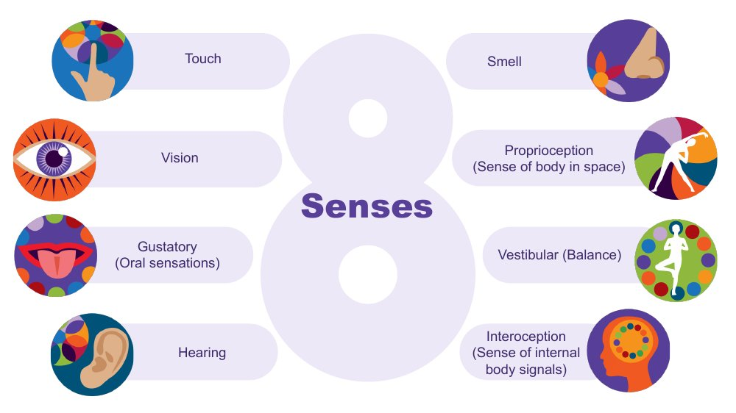 | The eight senses  SUGGESTED TIME  3 min  MINUTES INTO SESSION  32 - 35

Extend the familiar five senses to eight and introduce interoception to return to later.
WHAT TO DO  - Start from the five senses many of us were taught: touch, vision, taste, hearing and smell.  - Ask participants to name the three less well known senses in the chat or aloud. Give time to respond.  - Name them: proprioception, vestibular and interoception.  - Describe proprioception and vestibular with a school example for each.  - Name interoception and park it: say you will come back to it later in this session.  - Connect the senses to everyday classroom and playground environments. | KEY MESSAGES  - There are 8 senses, not 5.  - The hidden three are often where Autistic differences are most significant.  - Interoception is flagged here and picked up again at the end of this session.

YOU MIGHT SAY
Proprioception is the sense of where the body is in space. Students who crash into things, seek heavy pressure, or need to feel their body may be seeking proprioceptive input.
Vestibular is balance and movement. A student who needs to rock, spin, or keep moving in class may be regulating through this sense.
Interoception is the body's inside sense - and it is one of the most important for understanding a student's experience at school. Park it for now.
We will come back to interoception before the end of this session. It connects to a lot of what follows.

Background Touch (tactile) gives information about texture, pain, pressure and temperature. Vision gives depth, colour, size, shape and position. The gustatory sense includes taste and other oral sensations such as texture, temperature and how much pressure is needed when chewing. Hearing (auditory) tells us how far away, how loud and how familiar a sound is, and its pitch. Smell (olfactory) can link strongly to emotional memory. Proprioception comes through joints, muscles, ligaments and deep in the skin; differences may mean bumping into things. The vestibular sense sits in the middle ear, tracks speed and direction of head movement and supports balance; a student may love spinning, or may feel off balance on stairs. There is lots of crossover between the senses: in any situation we use all or most of them.
Thread Interoception returns in the internal signals slide (slide 16) later in this session.
RESOURCES
- Interoception webinar recording and resources on the Positive Partnerships website

SESSION 1 | Lens and Autistic Experience | SLIDE 12 of 18

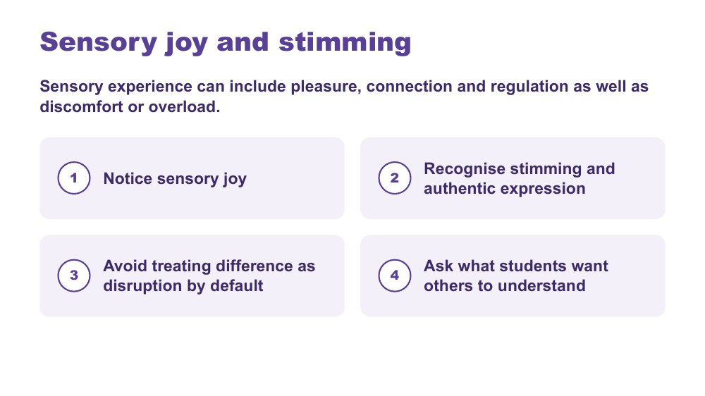 | Sensory joy and stimming  SUGGESTED TIME  2 min  MINUTES INTO SESSION  35 - 37

Recognise sensory joy, stimming and authentic expression as part of sensory experience.
WHAT TO DO  - Read the framing line: sensory experience can include pleasure, connection and regulation as well as discomfort or overload.  - Walk through the four points on the slide.  - Ask participants where they see sensory joy in the students they have in mind. They can note it privately or add a word to the chat. | KEY MESSAGES  - Sensory inquiry should include joy and authentic expression as well as discomfort or overload.  - Stimming can be pleasure, connection, regulation and authentic expression.  - Ask what students want others to understand.

KEEP IN MIND
- Do not discourage harmless stimming.
- Do not frame typical-looking behaviour as the goal.
- Avoid treating difference as disruption by default.

SESSION 1 | Lens and Autistic Experience | SLIDE 13 of 18

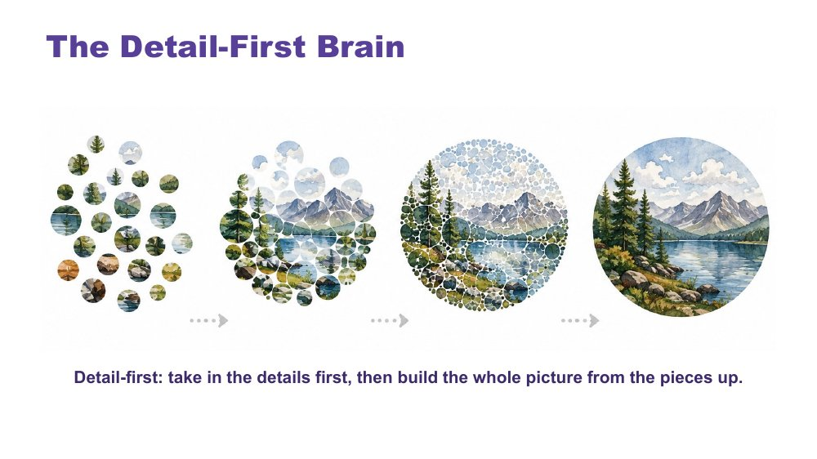 | The Detail-First Brain  SUGGESTED TIME  3 min  MINUTES INTO SESSION  37 - 40  PARTICIPANT GUIDE  Participant Guide - Strengths I can see

Introduce bottom-up, detail-first processing and the strengths it produces.
WHAT TO DO  - Open with the contrast between filtering first and taking in what is actually there.  - Name this as bottom-up processing.  - Read the caption on the slide aloud for anyone listening without video.  - Connect it to sensory intensity, literal language, pattern recognition and deep focus.  - Move through the strengths slowly: pattern recognition, systems thinking, deep memory, logical precision, honesty and directness, depth of connection, intense engagement.  - Invite a few chat responses connecting a strength to the students they have in mind, rather than working through every strength aloud.  - Invite participants to note strengths for Student A, B and C in the Participant Guide - Strengths I can see. | KEY MESSAGES  - Autistic cognition builds from detail up - bottom-up processing.  - This connects to sensory intensity, literal language, and everything that follows.  - The strengths listed are genuine features, not compensations.  - Educators who leave with vocabulary for these strengths will notice and build on them in the classroom.

YOU MIGHT SAY
Most brains filter first - they predict what is there based on expectation and fill in the rest. The detail-first brain does not filter first. It takes in what is actually there. Then it builds the whole picture from those pieces upward. That is bottom-up processing.
This is the architecture that connects sensory intensity, literal language, pattern recognition, and deep focus. They are not a list of separate Autistic traits. They are features of the same way of taking in the world.
Pattern recognition - where do you see this in class, and in which student?
Deep memory - what does one of them know by heart? Does it look different in another?
Honesty and directness - how does this show up at school?
These are not future potential. They are present now.

KEEP IN MIND
- Some educators may be used to a deficit or "despite" lens ("despite X they can Y"), a consolation prize approach. These are genuine features of how this brain works.
- Avoid turning the content into a deficit list.

Background Some research suggests stronger bottom-up signalling in Autistic brains, with less dominant top-down filtering. The environment is registered more fully, more specifically and less pre-organised before reaching conscious awareness. This produces precision and depth. It also produces load: the same fuller intake that supports pattern recognition can also lead to sensory overload. A student may pick up a tiny change in routine, a background sound, or an inconsistency in what someone said. They are not being pedantic. They are seeing accurately. The educator who names a student's pattern recognition as a strength is doing something meaningful for that student's identity and sense of self, and for how peers see them.

SESSION 1 | Lens and Autistic Experience | SLIDE 14 of 18

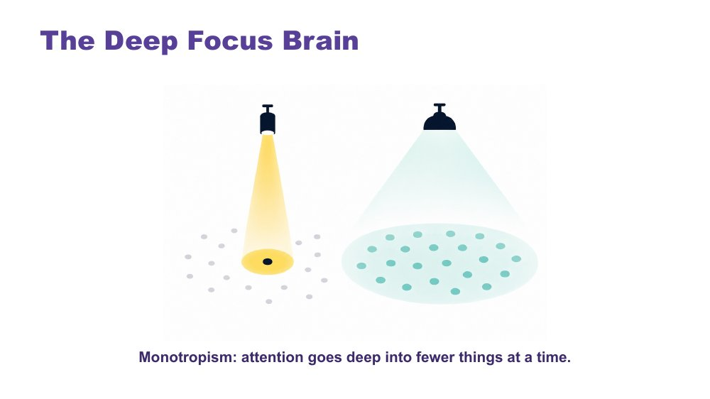 | The Deep Focus Brain  SUGGESTED TIME  3 min  MINUTES INTO SESSION  40 - 43

Introduce monotropism: deep focus, deep interests, transitions and flow.
WHAT TO DO  - Open with a question: do your thoughts travel across many topics, or go deep on one? Invite a reaction or a word in the chat.  - Give a moment to reflect.  - Move to the definition, using the visual on the slide.  - Read the caption on the slide aloud (monotropism: attention goes deep into fewer things at a time) for anyone listening without video.  - Name the key ideas: deep interests, transitions, flow.  - Use the recess example to show the cost of switching. | KEY MESSAGES  - Monotropism: deep focus on fewer things at a time, not distraction or obsession.  - Deep interests are the brain's most reliable route to learning, memory, and genuine engagement.  - Transitions have a real neurological cost - the attention is genuinely invested.  - Flow is the positive expression of this architecture - the brain at its best.  - Developed and extended with Autistic people.

YOU MIGHT SAY
Torch and floodlight: the non-Autistic brain tends to spread attention across many things at once, like a floodlight. The Autistic brain tends to channel it fully into one thing at a time, like a torch beam. Neither is wrong. They illuminate different things.
Tendril theory: the tendrils extend into whatever the mind is focused on. Switching means retracting all of them. That takes time and costs something.
River: the branching river spreads across many channels - broad, covering ground, but shallower in each stream. The single deep river goes all the way in one direction. Neither is wrong. The Autistic thinking brain tends to be the deep river, not scattered, not unfocused, going somewhere completely.
Deep interests are not obsessions or fixations. They are the brain's most natural access to learning, memory, and joy.
Transitions are hard not because the student is being difficult - but because the attention is genuinely, neurologically invested. The river does not change course quickly. With warning and scaffolding this becomes more manageable. The cost is always real.
Flow - full absorption, time disappearing - is this brain at its most powerful. It is worth protecting.
Asking a student absorbed in a construction task, reading about space, drawing or researching a topic they love to stop and pack up for recess is not a simple request. Their attention is fully in that task.

KEEP IN MIND
- Many educators will recognise this in themselves. That is fine to acknowledge, but keep the focus on the students.

Background Monotropism was developed as a framework by Dinah Murray, Mike Lesser and Wenn Lawson (Murray, Lesser and Lawson, 2005), and has been extended by Autistic community voices. It proposes that the core feature of Autistic attention is channelling into fewer things with greater depth, rather than distributing broadly. This explains deep interests, transition difficulty and the experience of flow.
Thread This connects directly to the detail-first brain: the same processing style, one explaining how the world arrives, one explaining where attention goes once it has.
RESOURCES
- Tendril theory comic - https://eisforerin.com/2015/08/10/tendril-theory/

SESSION 1 | Lens and Autistic Experience | SLIDE 15 of 18

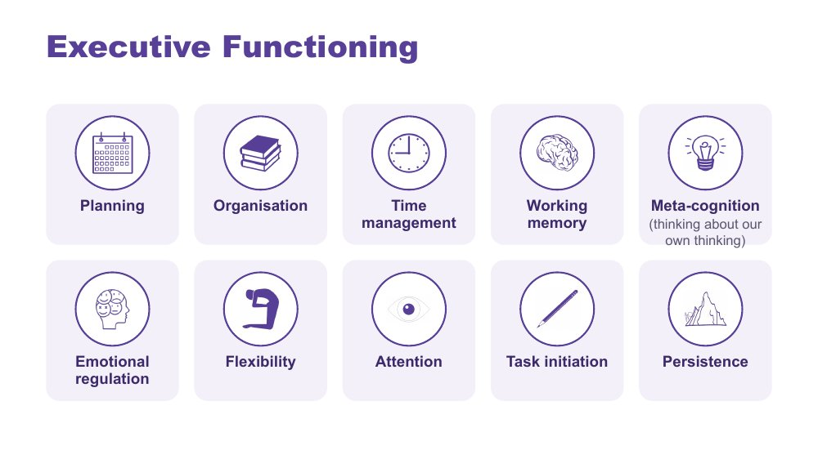 | Executive Functioning  SUGGESTED TIME  2 min  MINUTES INTO SESSION  43 - 45

Name the ten areas of executive functioning and link each to the demands of a school day.
WHAT TO DO  - Name the ten areas on the slide.  - Ask what a task asks the student to plan, start, remember, sequence, organise, switch and complete.  - Ask participants to think where each area shows up across an ordinary school day for the students they have in mind.  - If running behind, keep this brief: Session 3 returns to executive functioning supports. | KEY MESSAGES  - The terms are lenses for inquiry, not a checklist.  - Task design, timing and support can affect access.  - Explain each term before applying it.

YOU MIGHT SAY
Useful support responds to the specific demand rather than assuming a lack of effort or motivation. Different demands may need different kinds of support.

KEEP IN MIND
- Consider how instructions, interruptions, switching, starting, sequencing and task completion are organised in the setting, without claiming a single cause.
- Keep the focus on matching support to the individual student and context.

SESSION 1 | Lens and Autistic Experience | SLIDE 16 of 18

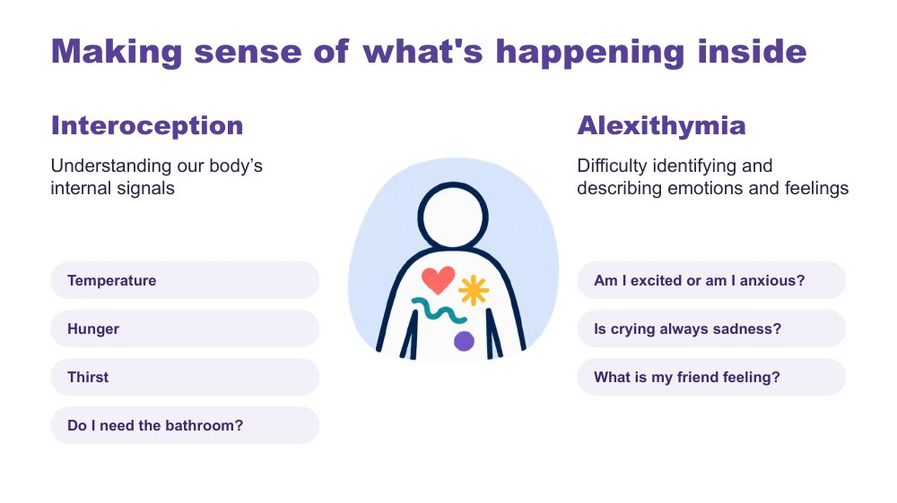 | Making sense of what's happening inside  SUGGESTED TIME  2 min  MINUTES INTO SESSION  45 - 47

Introduce interoception and alexithymia using the examples on the slide.
WHAT TO DO  - Introduce interoception: understanding our body's internal signals (temperature, hunger, thirst, needing the bathroom).  - Introduce alexithymia: difficulty identifying and describing emotions and feelings.  - Use the slide's questions as examples: Am I excited or am I anxious? Is crying always sadness? What is my friend feeling? | KEY MESSAGES  - Interoception helps answer the question "how am I doing?"  - Internal experience may not be visible to an observer.

KEEP IN MIND
- Name interoception and alexithymia without improvising definitions.
- Do not assume a student's internal state from outward behaviour.

Background Interoception is needed for knowing when to go to the toilet; knowing when you are tired, hungry or thirsty; knowing if you are hot or cold; being aware that you are becoming angry or upset. It plays a part in being able to self-regulate.
Thread Picks up the interoception seed planted on slide 11.

SESSION 1 | Lens and Autistic Experience | SLIDE 17 of 18

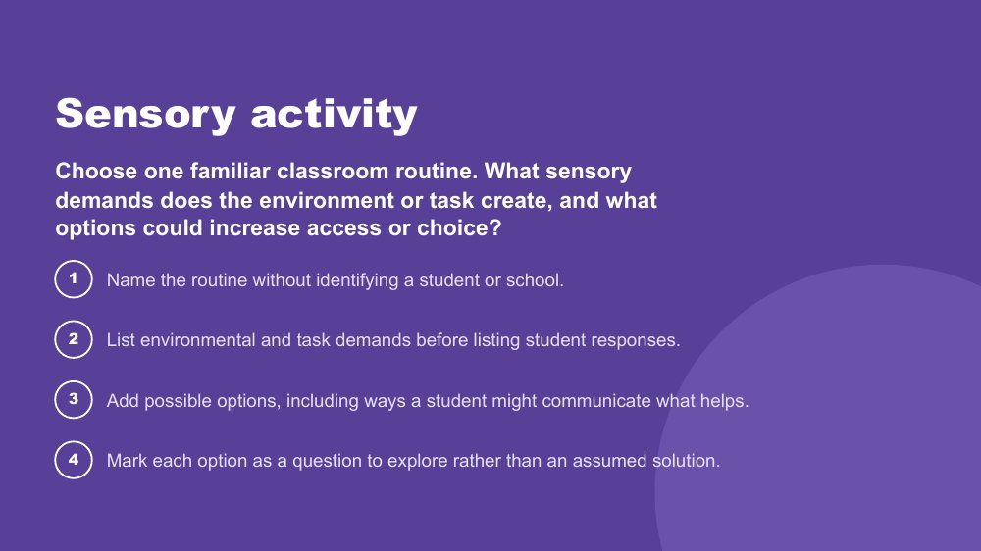 | Sensory activity  SUGGESTED TIME  11 min  MINUTES INTO SESSION  47 - 58  GROUPING  Breakout rooms of 2 or 3, with a main-room option  PARTICIPANT GUIDE  Participant Guide - Sensory activity

Apply an environment-first sensory lens to a familiar classroom routine, without simulating Autistic experience.
WHAT TO DO  - Producer pastes the prompt and the four steps into the chat before breakouts open.  - Read the prompt on the slide. Give examples of routines if needed, such as lining up, mat time, library visits or eating lunch.  - Give one minute for each person to choose a routine privately.  - Open breakout rooms of two or three for 6 minutes, plus about a minute for rooms to open and close. Anyone who prefers can stay in the main room and work on their own or with a facilitator.  - Ask participants to identify options and choice rather than one support for every student.  - Broadcast a one-minute warning before rooms close.  - Back in the main room, take one or two shares from the chat or aloud. Do not ask every room to report. | KEY MESSAGES  - Look at environmental and task demands before student responses.  - Options are questions to explore, not assumed solutions.  - One grounded question or change is enough for this activity.

ACTIVITY | Sensory activity breakout rooms of 2 or 3, with a main-room option · 11 minutes (1 minute to choose, 6 minutes in breakout rooms plus 1 minute for rooms to open and close, 3 minutes to debrief)
Choose one familiar classroom routine. What sensory demands does the environment or task create, and what options could increase access or choice?
- Name the routine without identifying a student or school.
- List environmental and task demands before listing student responses.
- Add possible options, including ways a student might communicate what helps.
- Mark each option as a question to explore rather than an assumed solution.
Bring the room back
- What could educators change, offer or investigate before increasing demands on the student?
Close: Ask what educators can change, offer or investigate before increasing demands on the student, and link this to the noticing task on the next slide.

KEEP IN MIND
- Do not run an autism simulation.
- Keep students and schools unidentifiable.
- Treat lighting, sound, movement, proximity, transitions and materials as participant-generated examples, not universal triggers.
- Initials or roles only in breakout rooms, and do not record them.

Background Main-room alternative: if breakouts are not possible, give five minutes of private writing using the four steps, then invite examples in the chat and group them under demands, options and questions.
RESOURCES
- Breakout rooms set to 2 or 3 per room
- Visible timer

SESSION 1 | Lens and Autistic Experience | SLIDE 18 of 18

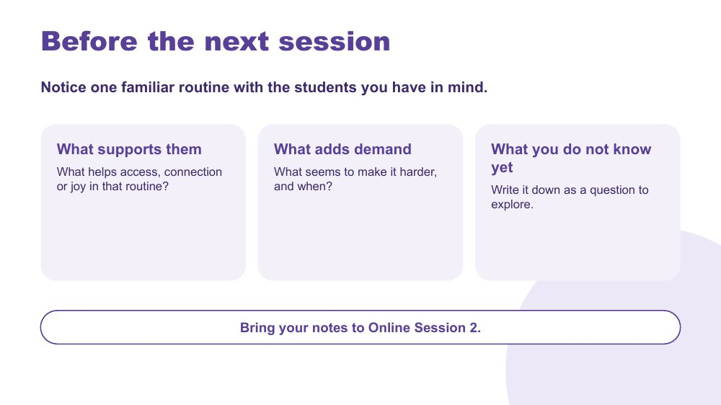 | Before the next session  SUGGESTED TIME  2 min  MINUTES INTO SESSION  58 - 60  PARTICIPANT GUIDE  Participant Guide - Before the next session

Close with a manageable noticing task that prepares participants for the school-day mapping in Online Session 2.
WHAT TO DO  - Walk through the three prompts on the slide: what supports them, what adds demand, what you do not know yet.  - Ask participants to notice one familiar routine they are already part of, with the students they have in mind.  - Explain that the task is optional and should not involve collecting identifiable information. Initials or roles only.  - Producer pastes the three prompts into the chat so people can copy them.  - Ask people to bring their notes to Online Session 2, and say that anyone who could not do it can still take part fully.  - Preview that Online Session 2 explores communication, connection and how demands build across a primary school day.  - Thank participants and give the next session date and joining details. | KEY MESSAGES  - Curiosity continues between sessions.  - Notice what supports access, connection and joy, not only what adds demand.  - What you do not know yet is worth writing down as a question.

YOU MIGHT SAY
You do not need to do anything extra with the students. Just notice one routine you are already part of, and write down what you see.

KEEP IN MIND
- Keep the task light. Some participants will not have a chance to do it before the next session.

Thread Online Session 2 opens by reconnecting with these notes and builds them into a map of the school day.

SESSION  2 | ONLINE · 60 MINUTES · 16 SLIDES  Communication, Connection and the Primary School Day

SESSION INTENT
Explore communication and connection through a whole-day lens, then help participants map how demands, supports, masking, identity and belonging can accumulate through a primary school day. Participants map a classroom day for the students they have in mind in the Participant Guide, individually or alongside colleagues in breakout rooms, and choose one focus to carry into design in Online Session 3.
PARTICIPANTS LEAVE WITH
- recognise that communication is multimodal and that how much a student speaks does not show how much they understand
- use double empathy to ask whose expectations shape an interaction, and name the many ways students connect
- map a primary school day, marking what costs, what lightens and what is not yet known for each of the students they have in mind
- choose one thing to keep, reduce and explore, carrying it into Online Session 3

RUN SHEET
Minutes in | Segment | Slides | Minutes
0 - 3 | Reconnect and orient | 1 | 3
3 - 15 | Communication | 2-5 | 12
15 - 27 | Connection and double empathy | 6-8 | 12
27 - 29 | Managing daily capacity | 9 | 2
29 - 47 | Map the primary school day: costs and lightens | 10-12 | 18
47 - 54 | Masking | 13-14 | 7
54 - 60 | Carry into design and close | 15-16 | 6

PREPARE
☐ Participant Guide (digital or printed) for every participant, including the day map pages
☐ Chat and reactions on; cameras optional
☐ Breakout rooms set up for pairs or trios, not recorded, with a main-room alternative
☐ Producer or co-host briefed to paste prompts into the chat and run breakouts
☐ Communication experiences video tested with screen share and sound, with edited captions and a transcript
☐ Communication experiences clip (slide 4) runs about 5.5 minutes: decide whether to play it all (and shorten slide 8) or stop at a set point
☐ Visible timer
☐ Closing image for slide 16 in place

Producer cues · Session 2
For the producer or co-host. At the start: admit participants, turn on captions, and paste the Participant Guide link and the session title in the chat. For each activity: paste the prompt before rooms open, broadcast a one-minute warning, and close rooms on time.
Slide | Activity | How | Time | Paste in the chat
4 | Communication experiences | whole group | 4 minutes | What stood out to you about what supported communication?
8 | Discussion activity: connection | pairs or trios in breakout rooms | about 5 minutes | When do the students you have in mind seem most comfortable connecting with others at school?
10 | Map a primary school day | on your own in the main room, or pairs or trios in breakout rooms | about 7 minutes | Map a typical day in your classroom, from arrival to departure. What are the routines, transitions, changes and moments that shape the day, and how do they affect each of the students you have in mind?
11 | What costs? What lightens? | on your own | about 4 minutes | What costs? What lightens? Where is a student's experience unknown?
14 | Discussion activity: masking | on your own, whole group for the last question | about 4 minutes | When might one of the students you have in mind be working hard to appear "fine" at school when they are not?
15 | Carry into design | on your own | about 2 minutes | Choose a clear focus for the next session.

SESSION 2 | Communication, Connection and the Primary School Day | SLIDE 1 of 16

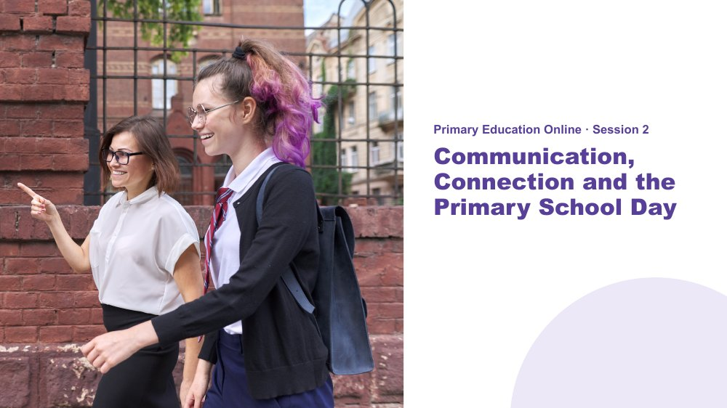 | Communication, Connection and the Primary School Day  SUGGESTED TIME  3 min  MINUTES INTO SESSION  0 - 3  PARTICIPANT GUIDE  Participant Guide - Session 2 key ideas

Welcome participants back, reconnect with the students they have in mind and introduce communication, connection and capacity across a primary school day.
WHAT TO DO  - Welcome participants back and restate the participation options: cameras optional; chat, reactions, speaking, private notes or passing all count.  - Invite participants to bring back the two or three students they have in mind from Session 1. Anyone new can choose students now, using initials or roles only.  - Give a quiet minute: since last session, what have you noticed about one of these students or a routine? Invite a word or short observation in the chat. Optional.  - Explain that the session moves from communication and connection into a day map in the Participant Guide.  - Remind participants they can step away from the screen at any time, and to keep examples within education practice and away from identifiable incidents. | KEY MESSAGES  - The primary school day is experienced through more than the timetable.  - Communication, connection, demand and belonging interact across the day.

YOU MIGHT SAY
Welcome back. Since last session, have you noticed anything new about one of the students you have in mind, or about a routine in your classroom? Take a quiet minute. If you would like to, pop a word or two in the chat. Initials or roles only.

KEEP IN MIND
- Do not assume everyone completed the between-session practice. Noticing nothing new is a fine answer.
- Do not ask anyone to identify a student or explain why they chose them.
- If running behind: shorten the connection breakout on slide 8 (3 minutes in rooms, one share in the debrief), and keep the masking discussion (slide 14) to private reflection with one chat response.

Thread Builds on the picture of the students started in Online Session 1, and leads into the design work in Online Session 3.

SESSION 2 | Communication, Connection and the Primary School Day | SLIDE 2 of 16

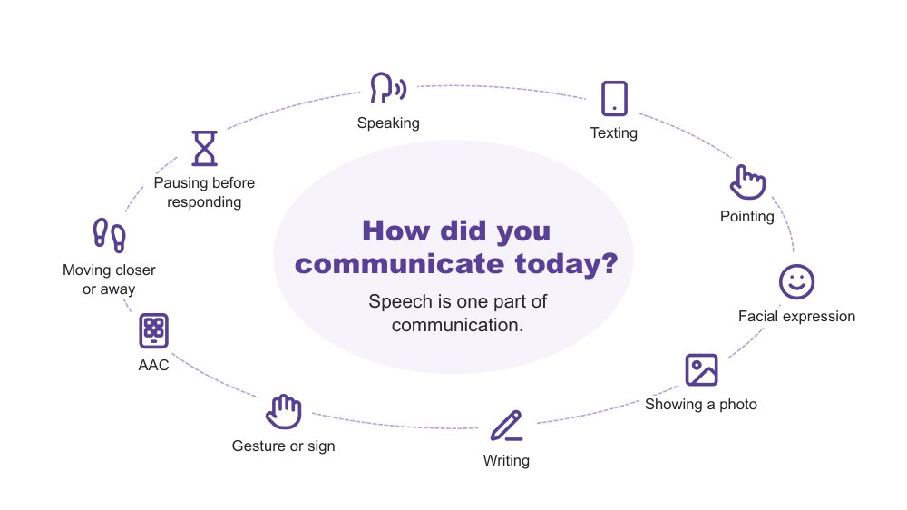 | How did you communicate today?  SUGGESTED TIME  2 min  MINUTES INTO SESSION  3 - 5

A quick warm-up showing that everyone communicates in many ways, every day.
WHAT TO DO  - Invite a quiet think: three ways participants have communicated today.  - Pause for about 20 seconds.  - Invite people to add one to the chat or use a reaction. Sharing is optional.  - Read out a few from the chat and reflect back the variety, for example a text message, a wave, a look, or taking a moment before answering. | KEY MESSAGES  - Everyone communicates in many ways, every day. Speech is one part of communication.

YOU MIGHT SAY
Let's start with a quick, quiet think. Since you woke up today, how have you communicated? See if you can think of three different ways.
If you are happy to, pop one in the chat.
We all move between different ways of communicating, often without noticing. Right now you are using the chat, reactions, your face on camera or not, and choosing when to unmute. Every way on this slide is real communication. No way is more valid than another.

KEEP IN MIND
- Keep this brief (1 - 1.5 minutes). It is a warm-up, not a discussion.
- Do not use percentages or claims about how much of communication is spoken or non-spoken.

Background Many students hear "use your words" at school. This is a gentle reframe for educators: pointing, a device, a look or moving away are all ways of communicating. The online room is a useful example: people are already choosing between chat, reactions, speaking and silence.

SESSION 2 | Communication, Connection and the Primary School Day | SLIDE 3 of 16

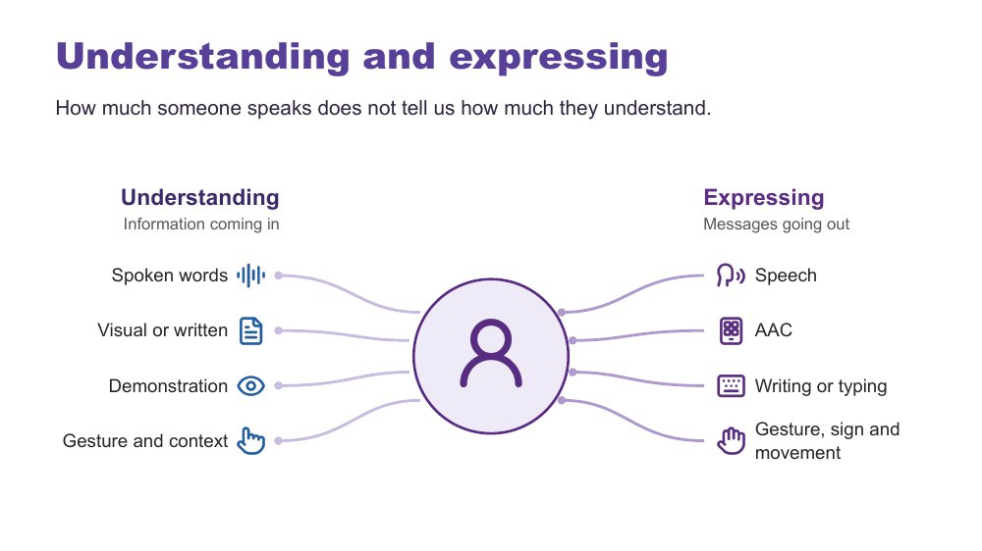 | Understanding and expressing  SUGGESTED TIME  3 min  MINUTES INTO SESSION  5 - 8

Separate understanding (receptive) from expressing (expressive) communication.
WHAT TO DO  - Explain that Autistic people have varied communication profiles.  - Name that someone may express a great deal but need support to understand spoken information, and someone else may understand more than they can easily express.  - Note that communication can change depending on the person, place, demands and how someone is feeling.  - Give the plain AAC explanation.  - Ask participants to think privately: what communication access do the environment and tasks in your classroom provide? | KEY MESSAGES  - How much someone speaks does not tell us how much they understand.  - Do not assume fluent speech means full understanding. Do not assume limited speech means limited understanding.  - Expressive and receptive communication do not necessarily look the same.

KEEP IN MIND
- Do not teach gestalt language processing (GLP) or Natural Language Acquisition stages here. It is background only.
- Do not ask participants to identify or diagnose a student as a gestalt language processor.
- Refer individual assessment or intervention questions to the student's speech pathologist or relevant team. If a detailed question comes up in the chat, acknowledge it and suggest this.

Background Receptive communication means how a person receives and makes sense of information. In primary school this includes teacher instructions, questions, classroom discussion, playground language, changes to routines and information about what is happening next. Expressive communication means how a person shares messages, ideas, feelings and choices through any communication method. AAC (augmentative and alternative communication) may include gesture, signs, a communication board or book, typing or a communication device; some people use it alongside speech and some instead of speech. Echolalia means repeating words or phrases, immediately or later, and can have communicative meaning. Gestalt language processing is a term used in a proposed account of learning language through larger phrases or chunks; the two terms are not interchangeable. Hutchins et al. (2024) question the evidence for these categories and stages. This does not diminish the value of repeated or scripted language: consider the possible context, intent and meaning, listen before correcting the form, and notice when and where it occurs and what follows. A student does not need a GLP label before their communication is respected or supported.
RESOURCES
- Hutchins et al. (2024) - https://doi.org/10.1177/23969415241249944

SESSION 2 | Communication, Connection and the Primary School Day | SLIDE 4 of 16

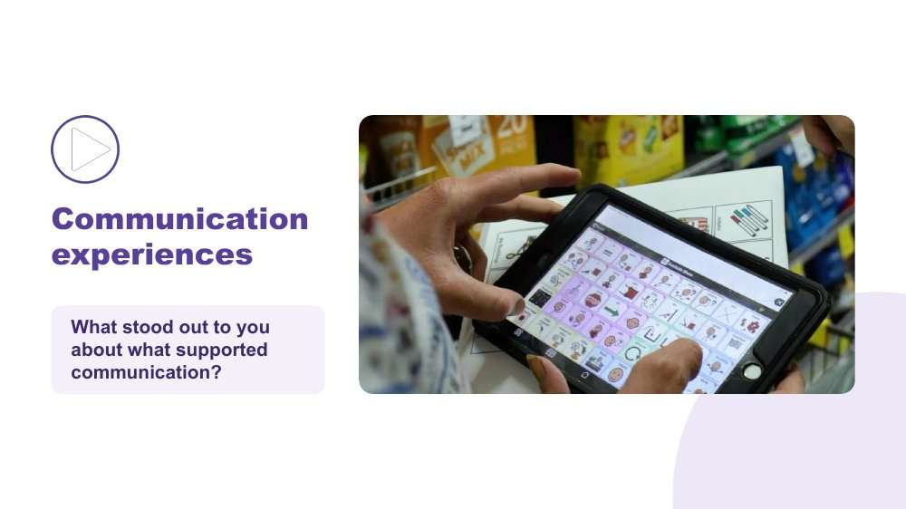 | Communication experiences  SUGGESTED TIME  4 min  MINUTES INTO SESSION  8 - 12  GROUPING  Whole group

Hear Autistic people describe what helps them communicate.
WHAT TO DO  - Share your screen with computer sound turned on, and check captions are showing.  - Read the prompt: "As you watch, notice what supports communication. Choose one idea that stands out to you."  - Play the video (it runs 5:31, about 5.5 minutes), or stop at the point you chose before the session.  - Stop sharing or click once to reveal the question.  - Invite responses in the chat or by unmuting. Read out one or two. | KEY MESSAGES  - There is no single Autistic communication profile. Autistic people describe what helps them communicate in many different ways.  - A student's AAC needs to be available where communication happens, not only during a specific activity or therapy session.

YOU MIGHT SAY
As you watch, notice what supports communication. Choose one idea that stands out to you.
What stood out to you about what supported communication? Pop it in the chat, or unmute if you would rather say it.

ACTIVITY | Video and brief whole-group response in the chat whole group · 4 minutes
What stood out to you about what supported communication?
- Watch the clip.
- Add one idea to the chat, or unmute.
- Facilitator reads out one or two.
Bring the room back
- What communication strengths did you notice?
- What did another person do that helped?
- What difference did the environment or available communication method make?

KEEP IN MIND
- The clip runs about 5.5 minutes. Decide before the session whether to play it all (and shorten slide 8, running the breakout for 3 minutes instead of 5, and keep slide 5 to 2 minutes) or stop at a set point.
- Let the voices in the video lead. Avoid summarising or generalising what speakers said.
- Use accurate, edited captions (not auto-generated only) and have a transcript available. The producer can paste the transcript link in the chat if one has been supplied.
- Test screen sharing with sound before the session. If video lags for participants, have the producer play it or share the file.

Background AAC adds to or provides an alternative to speech. In primary school this may include signs, communication boards or books and speech-generating devices, and it may be used alongside speech. The educator's role is not to assess or prescribe AAC. The focus is recognising and supporting the student's ways of communicating and working with the student, family and relevant team.

SESSION 2 | Communication, Connection and the Primary School Day | SLIDE 5 of 16

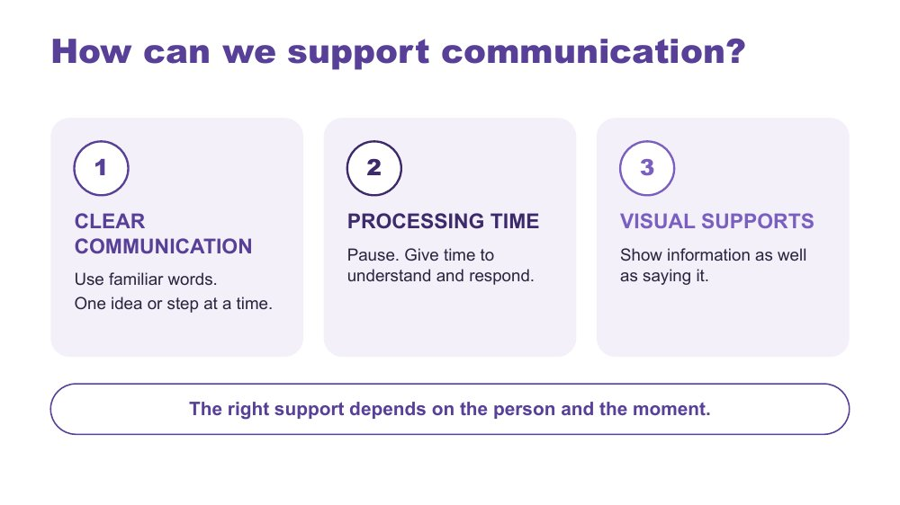 | How can we support communication?  SUGGESTED TIME  3 min  MINUTES INTO SESSION  12 - 15

Introduce three ways to support communication across the school day.
WHAT TO DO  - Link back to what people noticed in the video and the chat.  - Walk through the three strategies on the slide.  - Model the second one: after asking a question, pause and let the silence sit before anyone answers. | KEY MESSAGES  - The right support depends on the person and the moment.

YOU MIGHT SAY
There are three strategies we can use. Clear communication means using familiar words and giving one idea or step at a time. Processing time means pausing so the person has time to understand and respond. Visual supports mean showing information as well as saying it. Let's look at what these can look like.

KEEP IN MIND
- These are options to match to the person, not a checklist or a guarantee.
- Avoid filling every pause with more words. Online pauses can feel longer; hold them anyway.
- Keep AAC available and allow responses through the person's preferred methods, including refusal.

Background Processing time is time to make sense of information, organise a response and communicate it. Clear communication means familiar, specific language in a form and amount the person can access. Communication partner guidance includes adapting language and allowing response time, and AAC guidance also includes visual supports and access across settings (ASHA, n.d.; Brady et al., 2016). There is no activity on this slide.
RESOURCES
- ASHA (n.d.) - see References at the back of the Facilitator Guide
- Brady et al. (2016) - see References at the back of the Facilitator Guide

SESSION 2 | Communication, Connection and the Primary School Day | SLIDE 6 of 16

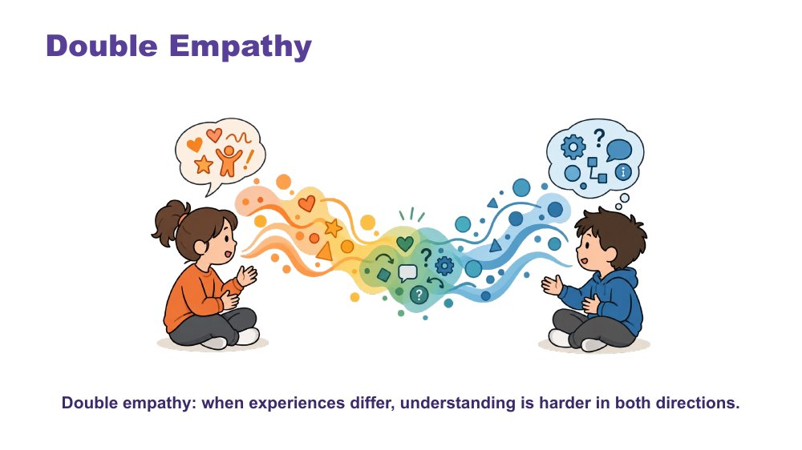 | Double empathy  SUGGESTED TIME  3 min  MINUTES INTO SESSION  15 - 18

Explore interaction and connection without treating one social style as the standard.
WHAT TO DO  - Explain double empathy: when people have different experiences and ways of communicating, understanding one another can be more difficult in both directions.  - Read the caption on the slide aloud for anyone listening without video.  - Ask whose expectations shape an interaction and what would make connection safer or clearer.  - Consider the expectations operating during classroom discussion, group work, playground interactions and interactions with adults and peers.  - Invite a short chat response if the group is ready: one place in the primary day where expectations about interaction are strongest.  - Use "how each student connects" throughout the discussion. | KEY MESSAGES  - Connection does not need to look one way.  - Interaction is shaped by expectations and context as well as by the student.  - Social misunderstanding does not automatically sit within the Autistic student.

YOU MIGHT SAY
Whose expectations are shaping this interaction?

KEEP IN MIND
- Move away from locating every social misunderstanding within the Autistic student.

Background Milton (2012), the double empathy problem.

SESSION 2 | Communication, Connection and the Primary School Day | SLIDE 7 of 16

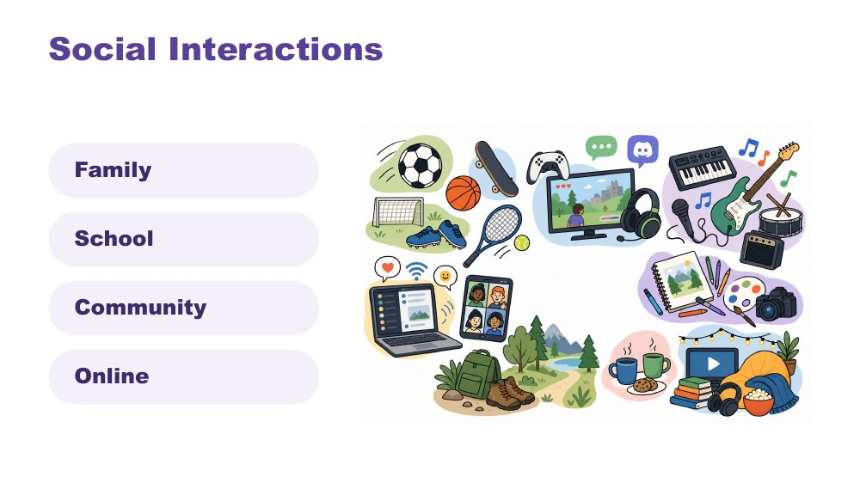 | Social interactions  SUGGESTED TIME  2 min  MINUTES INTO SESSION  18 - 20

Widen the picture of how students interact, across family, school, community and online.
WHAT TO DO  - Identify a range of ways a student may interact, for example 1:1, parallel play or engagement, info dumping, irregular contact.  - Make connections to culture.  - Name in-person, online and third spaces without making assumptions about a student's communities.  - Move straight on to the discussion, which puts this into practice. | KEY MESSAGES  - Connection can occur in person, online and in third spaces, and each student's experience is individual.

KEEP IN MIND
- Do not ask participants to disclose a student's online activity, identity or community membership.

SESSION 2 | Communication, Connection and the Primary School Day | SLIDE 8 of 16

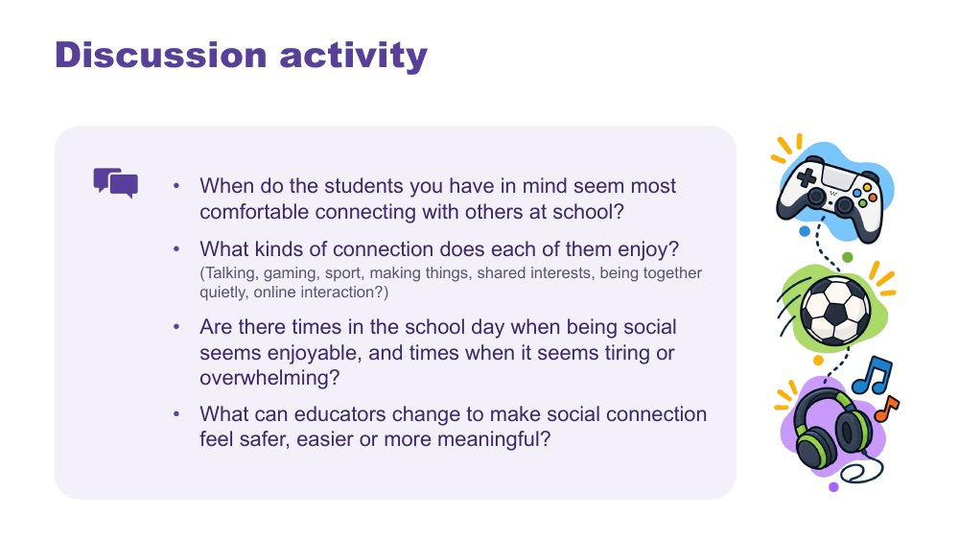 | Discussion activity: connection  SUGGESTED TIME  7 min  MINUTES INTO SESSION  20 - 27  GROUPING  Pairs or trios in breakout rooms  PARTICIPANT GUIDE  Participant Guide - Connection discussion

Apply the ideas of connection to the students participants have in mind.
WHAT TO DO  - Ask the producer to paste the four questions into the chat before opening breakout rooms.  - Open breakout rooms in pairs or trios for about 5 minutes. Remind people: initials or roles only, and breakout rooms are not recorded.  - Offer a main-room alternative: anyone who prefers can stay, think through the questions privately in the Participant Guide, or add thoughts to the chat.  - Broadcast a one-minute warning.  - Bring everyone back and take one or two responses from the chat or by voice, focusing on what educators can change. | KEY MESSAGES  - Connection does not need to look one way.  - What educators change around a student can make social connection feel safer, easier or more meaningful.

ACTIVITY | Guided discussion in breakout rooms, with a main-room alternative pairs or trios in breakout rooms · about 5 minutes
When do the students you have in mind seem most comfortable connecting with others at school?
- When do the students you have in mind seem most comfortable connecting with others at school?
- What kinds of connection does each of them enjoy? (Talking, gaming, sport, making things, shared interests, being together quietly, online interaction?)
- Are there times in the school day when being social seems enjoyable, and times when it seems tiring or overwhelming?
- What can educators change to make social connection feel safer, easier or more meaningful?
Bring the room back
- What could educators change around them to make social connection feel safer, easier or more meaningful?

KEEP IN MIND
- Do not ask participants to disclose a student's online activity, identity or community membership.
- Avoid interpreting difference as absence of connection.
- Keep the debrief to one or two shares. Not every room needs to report.

SESSION 2 | Communication, Connection and the Primary School Day | SLIDE 9 of 16

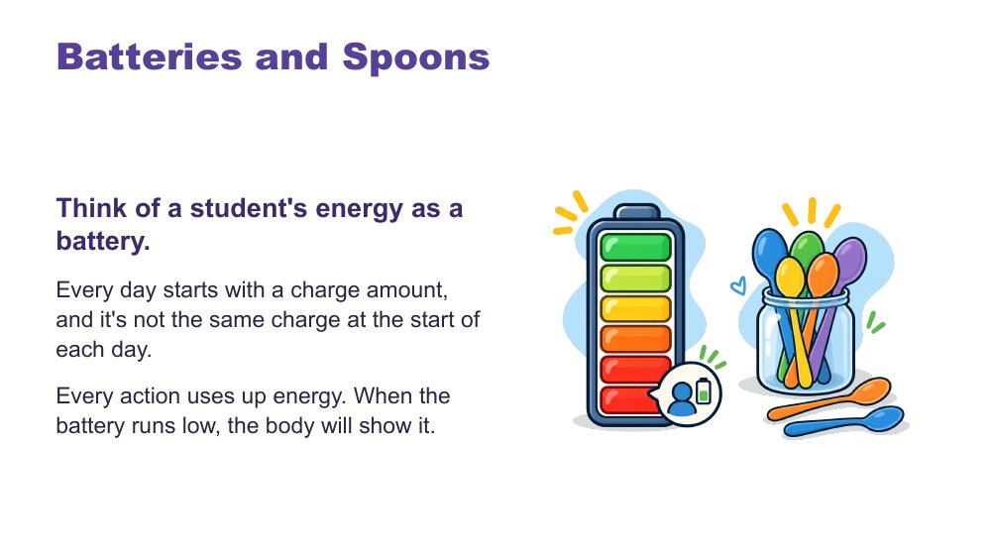 | Batteries and spoons  SUGGESTED TIME  2 min  MINUTES INTO SESSION  27 - 29

Give a shared language for energy and capacity.
WHAT TO DO  - Talk through the battery image.  - Introduce spoons as language many in the Autistic community use.  - Close on recharging: the right supports can restore some capacity.  - Let people know they will use this language in the day map next. | KEY MESSAGES  - Each day starts with a different charge.  - The right supports can recharge.

YOU MIGHT SAY
Think of a student's energy as a battery. Every day starts with a charge amount, and it's not the same charge at the start of each day. Every action uses up energy. When the battery runs low, the body will show it.
In the Autistic community, many like to describe this as having a set of spoons. Each action uses up one or some spoons. When "spoons are low", actions are hard to manage.
You can recharge! The right supports can regain some battery charge or extra spoons.

SESSION 2 | Communication, Connection and the Primary School Day | SLIDE 10 of 16

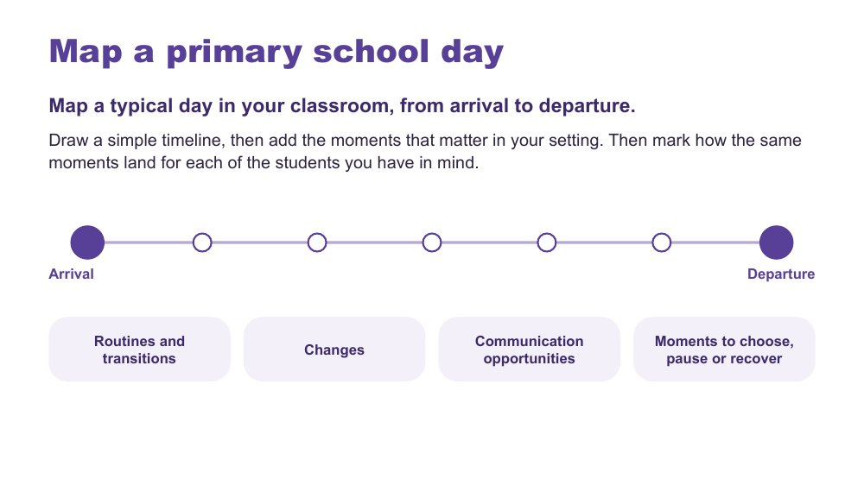 | Map a primary school day  SUGGESTED TIME  10 min  MINUTES INTO SESSION  29 - 39  GROUPING  On your own in the main room, or pairs or trios in breakout rooms  PARTICIPANT GUIDE  Participant Guide - Map a primary school day

Build a map of the whole primary school day, then mark how the same moments affect each of the students participants have in mind.
WHAT TO DO  - Ask participants to open the day map in the Participant Guide (digital or printed), or use a blank page.  - Explain the task: draw a simple timeline from arrival to departure, add the routines, transitions and changes that matter, then mark how the same moments affect each of the students they have in mind.  - Offer two ways to work: stay in the main room and map individually (cameras and microphones off is fine), or join a breakout room to map alongside one or two colleagues and talk it through.  - Ask the producer to paste the prompt into the chat, then open optional breakout rooms in pairs or trios for about 7 minutes.  - Encourage participants to follow the students' experience rather than copying only the official timetable.  - Link to cognitive load and capacity from the battery slide.  - Broadcast a one-minute warning, bring everyone back and let them know the next slide adds to the same map. | KEY MESSAGES  - The map is a working picture to extend, not a judgement of the student or school.

ACTIVITY | Individual map in the Participant Guide, or mapping alongside colleagues in breakout rooms on your own in the main room, or pairs or trios in breakout rooms · about 7 minutes
Map a typical day in your classroom, from arrival to departure. What are the routines, transitions, changes and moments that shape the day, and how do they affect each of the students you have in mind?
- Draw a simple timeline from arrival to departure.
- Add the routines and transitions that matter in your setting.
- Mark where each student can communicate, choose, pause or recover.
- In a breakout room, talk about patterns and routines, not the student.
- Keep the map private unless you choose to discuss it.
Close: The map is a working picture to extend, not a judgement of the student or school.

KEEP IN MIND
- Avoid names, school identifiers or unique incidents, especially in breakout rooms.
- Include communication opportunities, sensory demands, task changes, waiting, movement, breaks and recovery only where participants identify them from their context.
- Some people will find the whole day too much in the time. Suggest they map one part of the day, such as arrival to recess, and add to it later.

Thread Online Session 3 builds on this map.

SESSION 2 | Communication, Connection and the Primary School Day | SLIDE 11 of 16

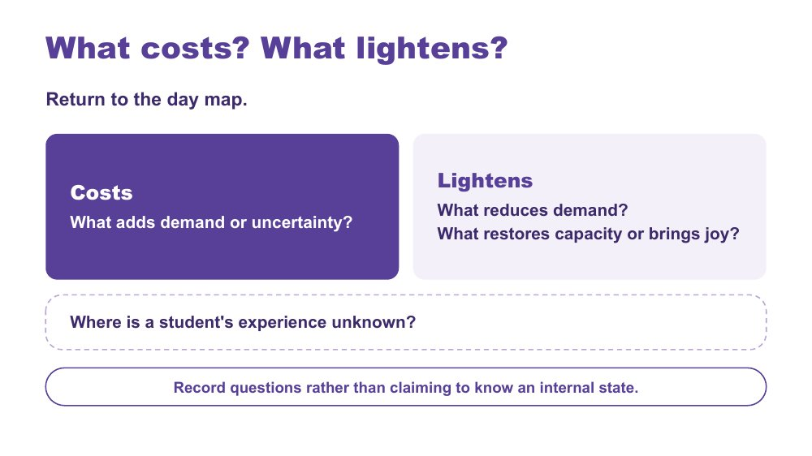 | What costs? What lightens?  SUGGESTED TIME  6 min  MINUTES INTO SESSION  39 - 45  GROUPING  On your own  PARTICIPANT GUIDE  Participant Guide - What costs? What lightens?

Extend the day map to show demand, relief and what is not yet known.
WHAT TO DO  - Ask participants to return to the day map.  - Ask them to mark what adds demand or uncertainty (costs).  - Ask them to mark what reduces demand, restores capacity or brings joy (lightens).  - Ask them to add questions where a student's experience is unknown.  - Link back to the battery language: what drains, what recharges.  - After about 4 minutes, invite one or two patterns in the chat under three headings: costs, lightens, questions. Read out one or two. | KEY MESSAGES  - A single moment sits within the demands and supports accumulated across the day.  - The map should include what lightens and restores as well as what costs.  - Record questions rather than claiming to know an internal state.

ACTIVITY | Extend the classroom-day map, with optional chat shares on your own · about 4 minutes
What costs? What lightens? Where is a student's experience unknown?
- Use one mark or colour for what costs.
- Use another for what lightens or restores.
- Add questions where the student's experience is not known.
- If you like, add one pattern to the chat: costs, lightens or a question.
Close: Look for patterns in the day that can inform what you carry into design.

KEEP IN MIND
- Do not turn the map into a score or a claim about internal state.
- Do not infer a student's internal state from a single behaviour or moment.
- Include strengths, joy, safe connection and belonging alongside costs.

Background Something can be enjoyable, valued or successfully completed and still require considerable effort. What costs or lightens will differ between students, and may differ for the same student across contexts and days.

SESSION 2 | Communication, Connection and the Primary School Day | SLIDE 12 of 16

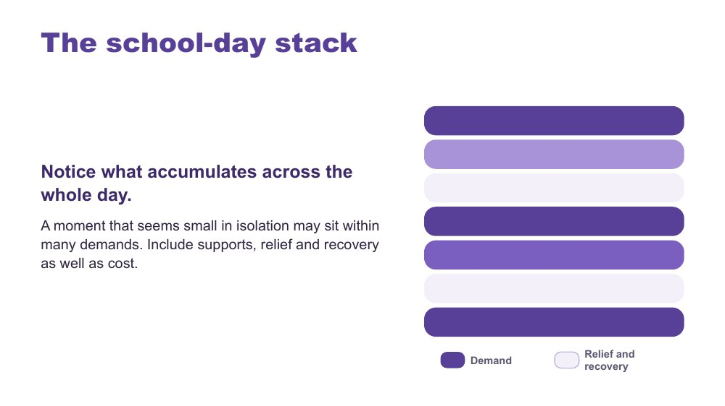 | The school-day stack  SUGGESTED TIME  2 min  MINUTES INTO SESSION  45 - 47

Show how demand accumulates across the whole day.
WHAT TO DO  - Use the stack model as presented.  - Point out that darker bars show demand and lighter bars show relief and recovery.  - Invite participants to glance back at their own map and notice where demand builds up.  - Keep the discussion qualitative. | KEY MESSAGES  - A moment that seems small in isolation may sit within many demands.  - Include supports, relief and recovery as well as cost.

KEEP IN MIND
- The stacked bars are a visual cue only. Do not score students.

SESSION 2 | Communication, Connection and the Primary School Day | SLIDE 13 of 16

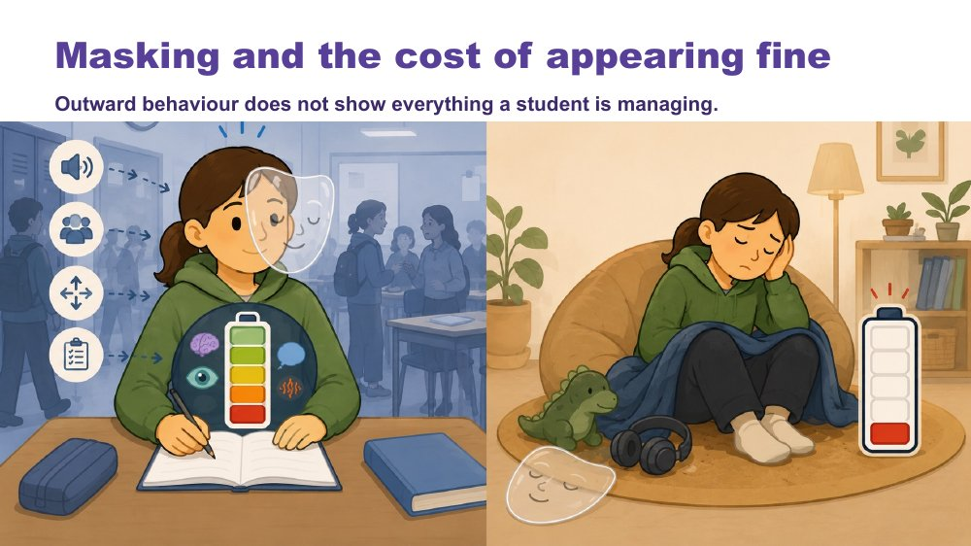 | Masking and the cost of appearing fine  SUGGESTED TIME  2 min  MINUTES INTO SESSION  47 - 49

Name what may be missed if educators look only at outward behaviour.
WHAT TO DO  - Read the caption on the slide aloud for anyone listening without video.  - Introduce masking in relation to identity and belonging.  - Pose the four questions for participants to think about privately.  - Ask what may be missed if educators look only at outward behaviour or task completion.  - Mention that this topic can bring up personal experience, and people are welcome to step away and come back. | KEY MESSAGES  - Outward behaviour does not show everything a student is managing.  - What is visible does not provide a complete account of capacity, identity or belonging.

KEEP IN MIND
- Avoid assuming that a student is coping because they are quiet, compliant or completing work.
- Include strengths, joy, safe connection and belonging alongside costs.

Background Prompts to pose: What might the student be working hard to manage or hide? Where can they be recognised and included? What supports belonging without requiring them to appear less Autistic? What does the student want others to understand?

SESSION 2 | Communication, Connection and the Primary School Day | SLIDE 14 of 16

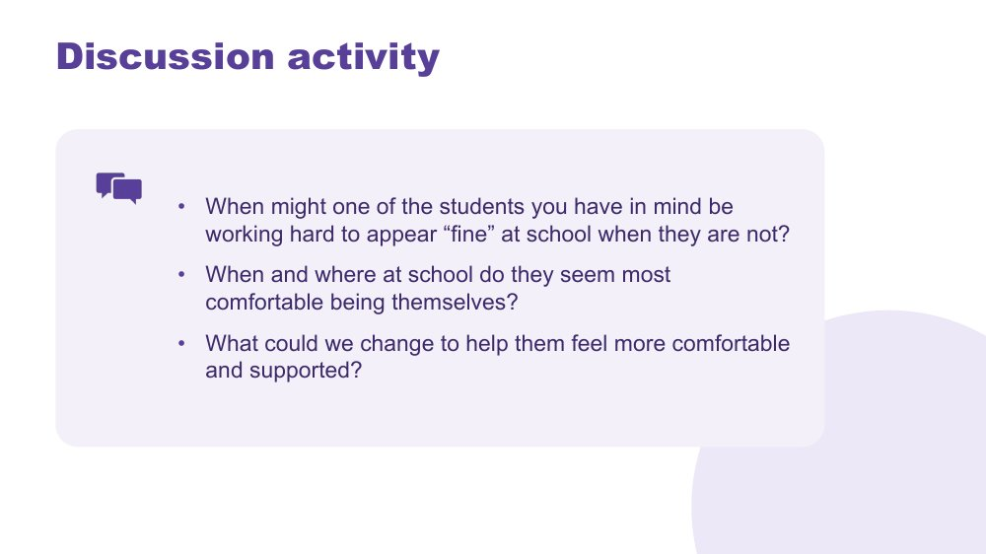 | Discussion activity: masking  SUGGESTED TIME  5 min  MINUTES INTO SESSION  49 - 54  GROUPING  On your own, whole group for the last question  PARTICIPANT GUIDE  Participant Guide - Masking discussion

Apply masking to the students participants have in mind.
WHAT TO DO
- Ask the producer to paste the three questions into the chat.
- Give about 3 minutes of private reflection in the Participant Guide. The first two questions stay private.
- Invite responses to the last question only, in the chat or by unmuting.
- Read out one or two responses on what could change.

ACTIVITY | Private reflection with optional chat response on your own, whole group for the last question · about 4 minutes
When might one of the students you have in mind be working hard to appear "fine" at school when they are not?
- When might one of the students you have in mind be working hard to appear "fine" at school when they are not?
- When and where at school do they seem most comfortable being themselves?
- What could we change to help them feel more comfortable and supported?
Bring the room back
- What could we change to help them feel more comfortable and supported?

KEEP IN MIND
- Avoid assuming that a student is coping because they are quiet, compliant or completing work.
- Keep examples anonymised. The chat is visible to everyone and may be saved.
- If time is available, this can run as a short breakout in pairs instead, with the same last question for the debrief.

SESSION 2 | Communication, Connection and the Primary School Day | SLIDE 15 of 16

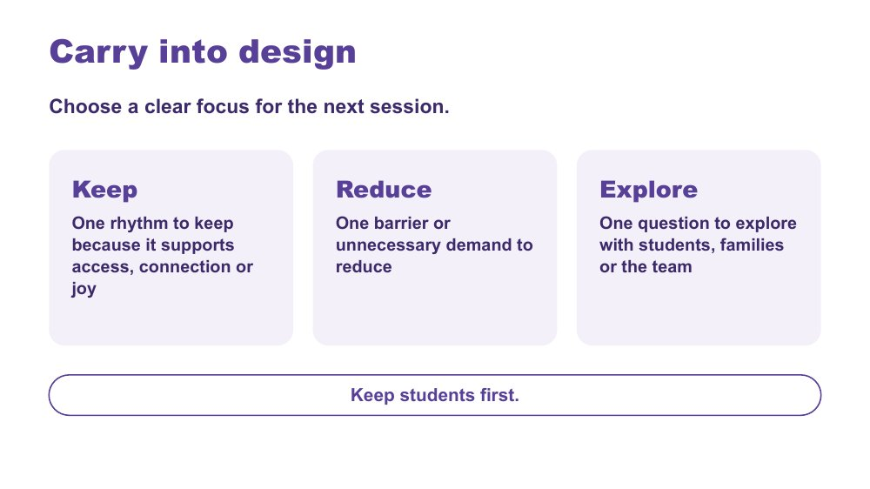 | Carry into design  SUGGESTED TIME  3 min  MINUTES INTO SESSION  54 - 57  GROUPING  On your own  PARTICIPANT GUIDE  Participant Guide - Carry into design

Consolidate the school-day inquiry and choose a focus for Online Session 3.
WHAT TO DO  - Invite participants to identify one rhythm to keep, one barrier to reduce and one question to explore, in the Participant Guide.  - Ask participants to tick whether their Reduce item is a rotation, a transition or a whole-class routine. They will use this in Online Session 3.  - Keep responses private unless participants choose to share.  - Ask participants to keep their map for the design activity next session.  - Preview the move from the classroom-day map to one practical classroom design change. | KEY MESSAGES  - Design should protect what supports access, connection and joy as well as reduce barriers.  - Unanswered questions can guide consultation with the student, family and team.  - Keep students first.

ACTIVITY | Carry into design (Keep, Reduce, Explore) in the Participant Guide on your own · about 2 minutes
Choose a clear focus for the next session.
- Keep: one rhythm to keep because it supports access, connection or joy.
- Reduce: one barrier or unnecessary demand to reduce.
- Tick: rotation, transition or whole-class routine.
- Explore: one question to explore with students, families or the team.
Close: Keep your map and your Keep, Reduce, Explore notes for Online Session 3.

Thread Leads directly into the Online Session 3 design brief.

SESSION 2 | Communication, Connection and the Primary School Day | SLIDE 16 of 16

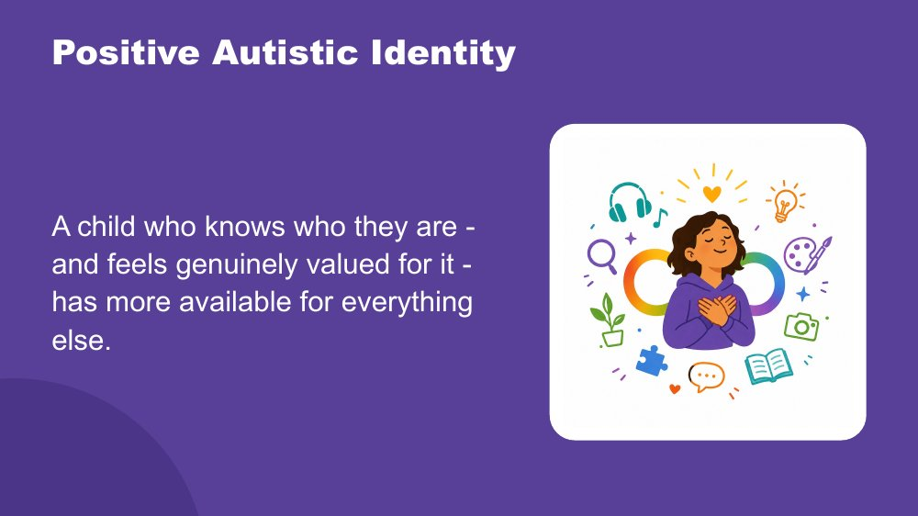 | Positive Autistic identity  SUGGESTED TIME  3 min  MINUTES INTO SESSION  57 - 60

Close the session by returning to the students participants have in mind, seen now with a fuller picture.
WHAT TO DO  - Let the room settle before you begin. You might invite people to turn off self-view or look away from the screen.  - Read the spoken close slowly, with the image on the screen.  - Pause. Let it land. Do not fill the silence.  - Thank participants, give the date of Online Session 3 and ask them to bring their map and Keep, Reduce, Explore notes. | KEY MESSAGES  - The cost is not just masking. It is managing the whole of Autistic experience in a world not designed for it.  - Positive Autistic identity is a research-supported protective factor for mental health and wellbeing.  - Belonging is the precondition. When identity does not need to be managed on top of everything else, those resources become available for learning and connection.  - Agency is protective. Genuine choice over their own environment reduces cost directly.  - Autistic community connection is itself protective. Knowing other Autistic people share your experience matters.

YOU MIGHT SAY
Across these first two sessions, you have been building a picture of the students you have in mind.
How the world arrives through their senses, more fully, more specifically, less filtered. How their brain builds understanding from the detail up, focuses deeply, and thinks in ways that produce real and specific strengths. How their internal world works. How they reach toward other people, and what that costs when the conditions are not designed for them.
Managing all of that, every day, in a world that was largely built for a different nervous system, takes resources. Sensory management. Social interpretation. Executive effort. Communication across a gap. Holding it together when the signals inside are not arriving clearly. And sometimes, performing fine when fine is not what is happening.
A child who knows who they are - and feels genuinely valued for it - has more of those resources available for everything else.
Research supports what many Autistic adults already know: a positive sense of Autistic identity is connected to better mental health, less anxiety, and greater wellbeing. Belonging is the precondition for all of it. When a child does not need to spend resources managing their identity on top of everything else, those resources become available for learning, connection, and self-knowledge.
Agency matters too, genuine choice over how they communicate, where they sit, when they step back. And knowing that other Autistic people share their experience, that Autistic adults have found belonging and purpose, is protective in its own right.
These students are not alone in this. They are part of something.
The deepest thing you can do is support them to know themselves, and to know that who they are is worth knowing.

KEEP IN MIND
- The opening lines draw together what Online Sessions 1 and 2 covered. Let participants make the connections themselves rather than telling them what to conclude.
- The final sentence is the one to leave with people. Leave a few seconds of quiet before closing the meeting; do not end the call straight after the last line.

Background Research on Autistic identity and wellbeing shows that positive Autistic identity, knowing yourself as Autistic and valuing that, is associated with better mental health outcomes, reduced anxiety and greater resilience. This is distinct from general self-esteem: it is specifically the sense of Autistic identity as something to know and value, not manage or minimise, that provides protection. Belonging to Autistic peer networks adds to this. The goal is not for students to fit in. The goal is for each student to know who they are, and to find the people and places where that is valued. See Cooper, Smith and Russell (2017); Corden, Brewer and Cage (2021).
Thread Returns to the students participants brought to mind in Online Session 1.

SESSION  3 | ONLINE · 60 MINUTES · 16 SLIDES  Designing for Access in the Primary Classroom

SESSION INTENT
Participants move from understanding to design by redesigning one real classroom routine (a rotation, a transition or a whole-class routine) through an environment-first brief, a menu of support options and a universal-first accessibility check. Each person develops the change in their Participant Guide and checks it with a breakout partner, then privately tests it against the two or three students they have in mind, which opens the continuum of support, before a personal commitment.
PARTICIPANTS LEAVE WITH
- write an environment-first brief for one real classroom routine, free from blame or deficit labels
- match one or two support options to a known demand in that routine and test the design for accessibility
- check the design against the students they have in mind and locate where targeted or individual support begins on the continuum
- leave with one thing to try and who they will involve

RUN SHEET
Minutes in | Segment | Slides | Minutes
0 - 7 | Reconnect and students first | 1-3 | 7
7 - 14 | Brief | 4 | 7
14 - 25 | Options | 5-8 | 11
25 - 31 | Universal first | 9-10 | 6
31 - 43 | Design and breakout check | 11 | 12
43 - 48 | Check against your students | 12 | 5
48 - 56 | Continuum and NCCD | 13-15 | 8
56 - 60 | Commit and close | 16 | 4

PREPARE
☐ Participant Guide (digital or printed) for every participant: My brief, My design, My students check and Commit sections.
☐ Ask participants to bring their day map and Carry into design notes (Keep, Reduce, Explore) from Online Session 2.
☐ Brief the producer: breakout pairs ready for slide 11 (about 5 minutes), plus a main-room option.
☐ Chat prompts ready to paste: brief stems, the five design steps and pair check, commitment questions.
☐ An approved composite primary example for anyone without a suitable routine or student in mind.
☐ Visual Supports Checklist and details of the visual supports webinar (links to confirm).
☐ Current official NCCD information to share in the chat.

Producer cues · Session 3
For the producer or co-host. At the start: admit participants, turn on captions, and paste the Participant Guide link and the session title in the chat. For each activity: paste the prompt before rooms open, broadcast a one-minute warning, and close rooms on time.
Slide | Activity | How | Time | Paste in the chat
4 | Write your brief | on your own | 7 minutes (about 5 minutes writing, 2 minutes chat share) | Choose one routine you know well, then write an environment-first brief.
10 | Accessibility check | on your own | about 4 minutes | Run these over your draft design, then test it through use and feedback.
11 | Finish your design | on your own, then breakout pairs | 12 minutes (about 7 minutes design, 5 minutes pair check) | Develop the change in your Participant Guide.
12 | Check the design against your students | on your own | 5 minutes | Privately, test your design against each of your students.
16 | Share, refine and commit | on your own | about 4 minutes | What will you try? What will you notice? Who needs to be involved? How will students and families help refine it?

SESSION 3 | Designing for Access in the Primary Classroom | SLIDE 1 of 16

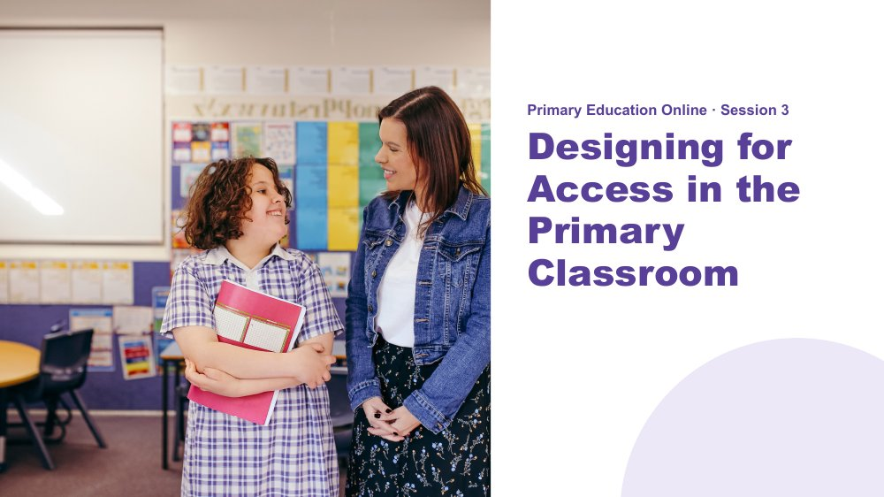 | Session 3 / Designing for Access in the Primary Classroom  SUGGESTED TIME  3 min  MINUTES INTO SESSION  0 - 3  PARTICIPANT GUIDE  Participant Guide - Session 3 key ideas

Reconnect with the day map and design question from last session, and shift from understanding experience to designing access in a primary classroom.
WHAT TO DO  - Welcome participants back as they join. Remind them that cameras are optional and that chat, reactions, speaking, private notes or passing all count.  - Ask them to have their Participant Guide open, with the day map and Carry into design notes (Keep, Reduce, Explore) from last session to hand.  - If someone missed Session 2, they can make a quick sketch of a typical day (arrival to home time) and join a breakout partner's day map for the design work.  - Invite one or two people to share in the chat, using initials or roles only, anything they noticed since last session about the barrier they chose to reduce.  - Name the student-to-classroom direction of the session.  - Explain that the session will produce one small, testable design change that each person works on in their own Participant Guide.  - Keep the focus on environment, task and routine rather than changing the student. | KEY MESSAGES  - What we know about students informs design; it is not a list of deficits.  - A practical change should respond to a barrier or access question.

KEEP IN MIND
- Remind people they can step away from the screen at any time.
- Some people will have missed Session 2 and have no day map. A quick sketch of a typical day is enough; pair them with someone who has a map.
- If running behind: keep each option input (slides 6 to 8) to about two minutes, and trim NCCD (slide 15) to the producer pasting the link and you reading the Disability Standards line.

Thread Picks up the primary day map, costs and lighteners and the Carry into design notes (especially "Reduce") from Online Session 2.

SESSION 3 | Designing for Access in the Primary Classroom | SLIDE 2 of 16

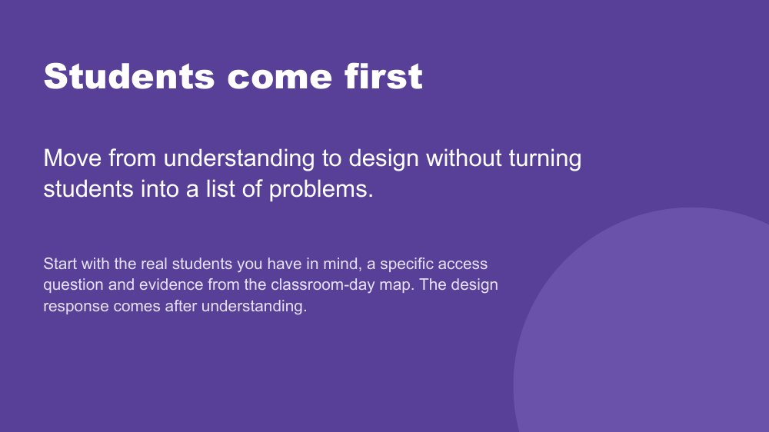 | Students come first  SUGGESTED TIME  2 min  MINUTES INTO SESSION  3 - 5

Set the principle that understanding real students comes before any design response.
WHAT TO DO  - Point to the students participants have in mind and the day map from last session.  - Name that the session designs for one classroom routine, then checks that design against the two or three students each person has in mind.  - Remind participants to include only what is known, and to hold unknowns as questions.  - Ask participants to separate an observation from an interpretation, and a question from a conclusion. | KEY MESSAGES  - Understand the student before choosing a strategy.  - A design brief connects what matters for students with what can change in the environment, task or routine.  - Unknowns remain questions for consultation.

KEEP IN MIND
- Do not use what is known about students to diagnose, rank or reduce them to support needs.
- Initials or roles only in the chat and in breakout rooms.

Thread Draws on the day map from Online Session 2.

SESSION 3 | Designing for Access in the Primary Classroom | SLIDE 3 of 16

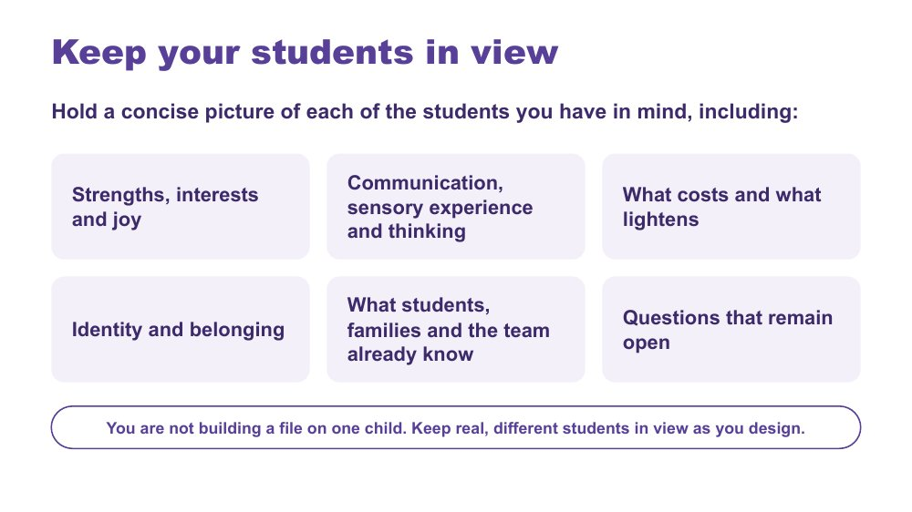 | Keep your students in view  SUGGESTED TIME  2 min  MINUTES INTO SESSION  5 - 7

A quick reminder to hold a concise picture of each student in mind while designing.
WHAT TO DO  - Keep this to about one to two minutes.  - Run through the areas on the slide as prompts, not a form to fill in.  - Invite participants to jot private notes if it helps; nothing here is shared.  - Name that participants will come back to these students later in the session, in the private check. | KEY MESSAGES  - You are not building a file on one child. Keep real, different students in view as you design.  - Include strengths, interests and joy, communication, sensory experience, thinking, costs, lighteners, identity and belonging only where these are known or framed as questions.

KEEP IN MIND
- Do not use this to diagnose, rank or reduce students to support needs.

SESSION 3 | Designing for Access in the Primary Classroom | SLIDE 4 of 16

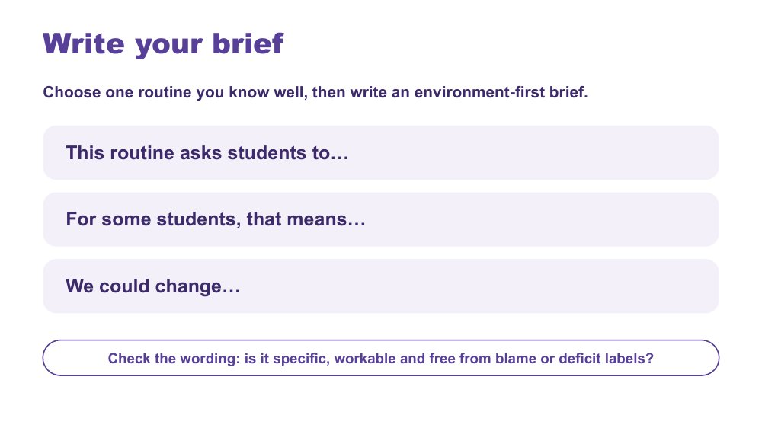 | Write your brief  SUGGESTED TIME  7 min  MINUTES INTO SESSION  7 - 14  GROUPING  On your own  PARTICIPANT GUIDE  Participant Guide - My brief

Each person chooses one routine they know well and writes an environment-first design brief for it.
WHAT TO DO  - Ask the producer to paste the three stems into the chat.  - Ask each person to choose one routine they know well: a rotation, a transition or a whole-class routine. It may come from their "Reduce" note last session.  - Give about five minutes to complete the three stems in the Participant Guide.  - Check that the brief points to something within educator or school influence.  - Prompt participants to remove any wording that blames or labels students.  - Invite one or two people to paste their "We could change..." line into the chat, and read one aloud. | KEY MESSAGES  - A design brief connects what matters for students with what can change in the environment, task or routine.  - Unknowns remain questions for consultation.

ACTIVITY | Individual design brief in the Participant Guide, with optional chat share on your own · 7 minutes (about 5 minutes writing, 2 minutes chat share)
Choose one routine you know well, then write an environment-first brief.
- Choose one routine you know well: a rotation, a transition or a whole-class routine.
- Complete: "This routine asks students to..."
- Complete: "For some students, that means..."
- Complete: "We could change..."
- Check the wording: is it specific, workable and free from blame or deficit labels?
Bring the room back
- Optional: paste your "We could change..." line into the chat.
Close: Keep this one brief active for the rest of the session.

KEEP IN MIND
- Watch for observation drifting into interpretation, or questions presented as conclusions.

Background If someone has no suitable routine in mind, offer the approved composite primary example.

SESSION 3 | Designing for Access in the Primary Classroom | SLIDE 5 of 16

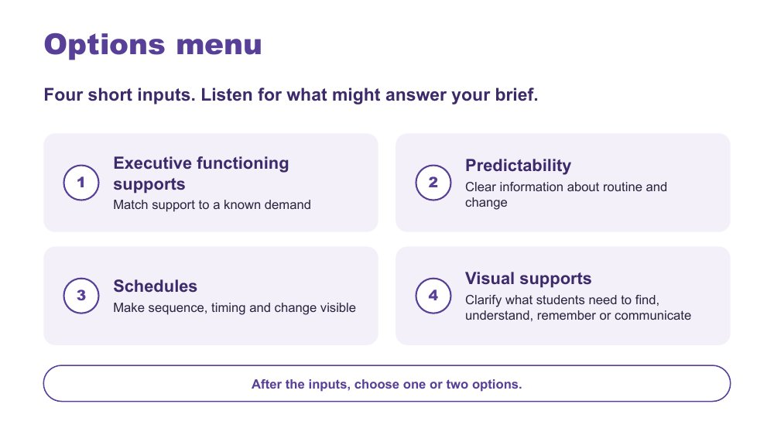 | Options menu  SUGGESTED TIME  2 min  MINUTES INTO SESSION  14 - 16

Frame the short inputs as a menu that participants listen to with their brief in front of them.
WHAT TO DO  - Ask participants to keep their brief visible, in the Participant Guide or on screen beside Zoom.  - Ask them to listen for which option might answer "This routine asks students to..."  - Name the four options: executive functioning supports, predictability, schedules and visual supports. Schedules is option 3 and sits on the Predictability slide (slide 7): a schedule makes sequence, timing and change visible.  - Keep each of the following inputs to about three minutes.  - Invite people to note in the chat which option they are leaning towards, if they wish. | KEY MESSAGES  - Listen for what might answer your brief.

SESSION 3 | Designing for Access in the Primary Classroom | SLIDE 6 of 16

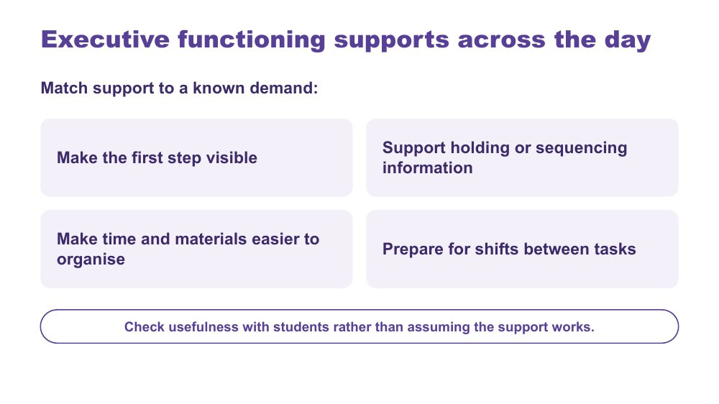 | Executive functioning supports across the day  SUGGESTED TIME  3 min  MINUTES INTO SESSION  16 - 19

Option 1 of 4: executive functioning supports matched to a known demand.
WHAT TO DO  - Keep this input to about three minutes.  - Use support examples only.  - Link examples to the day map and each person's brief rather than presenting a strategy checklist.  - Ask which task demands are being supported and how students can show whether the support helps.  - Optional: invite one example in the chat of a first step that could be made visible. | KEY MESSAGES  - Support should answer a known demand or question.  - Students' experience helps determine whether a support is useful.  - A support should reduce unnecessary demand rather than increase compliance pressure.

KEEP IN MIND
- Avoid assuming that the same support works across students or contexts.

SESSION 3 | Designing for Access in the Primary Classroom | SLIDE 7 of 16

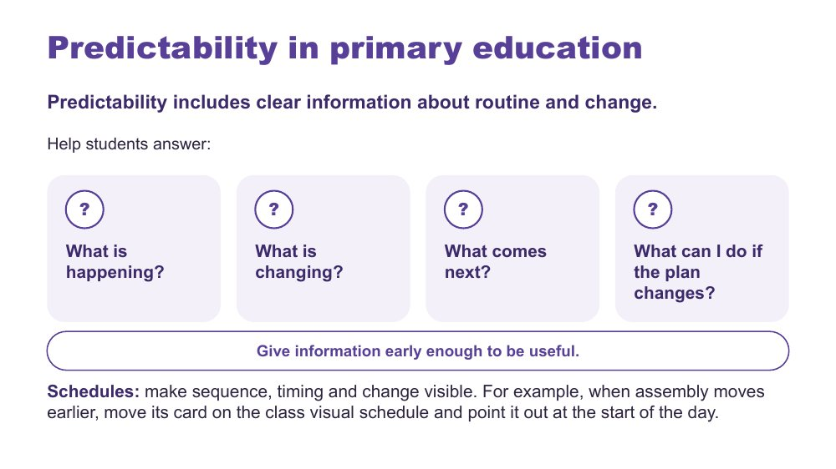 | Predictability in primary education  SUGGESTED TIME  3 min  MINUTES INTO SESSION  19 - 22

Options 2 and 3 of 4: predictability as access to information about routine and change, and schedules as one way to make sequence and change visible.
WHAT TO DO  - Keep this input to about three minutes.  - Frame predictability as access to information, not making every day the same or removing unexpected change.  - Draw attention to how much information in a primary school day is spoken, implied or held by adults.  - Connect back to the day map from last session: when something in the day changes, how do students find out?  - Use the four questions on the slide to examine what information is available to students.  - Point to the Schedules line (option 3): a schedule makes sequence, timing and change visible. Use the example on the slide: when assembly moves earlier, move its card on the class visual schedule and point it out at the start of the day.  - If needed, extend the assembly example with the questions below. | KEY MESSAGES  - Predictability is access to information, not a promise that nothing will change.  - Clear information about change can be just as important as information about routine.  - Schedules make sequence, timing and change visible, including when the plan changes.  - A visual support is an option, not a universal prescription.  - Useful supports are reviewed through experience and feedback.

YOU MIGHT SAY
If I couldn't rely on remembering what someone had told me, how would I know what was happening in this classroom?
Predictability is not the absence of change. It includes having accessible information when change happens.

Background Primary example if needed: assembly is moved earlier than usual. How will students know the plan has changed? Is the change on their schedule or support? Can they return to that information? Can they see what happens next? Do they have an accessible way to ask a question or say they need more information or support? Students may otherwise be expected to listen, remember, infer or ask in order to know what is happening.
Thread Links back to the day map and school-day stack from Online Session 2.

SESSION 3 | Designing for Access in the Primary Classroom | SLIDE 8 of 16

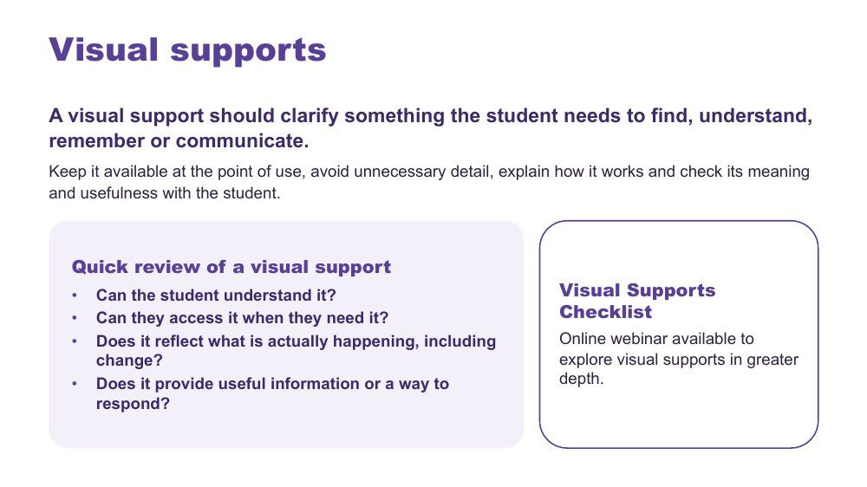 | Visual supports  SUGGESTED TIME  3 min  MINUTES INTO SESSION  22 - 25  PARTICIPANT GUIDE  Participant Guide - Quick review of a visual support

Option 4 of 4: visual supports that clarify what students need to find, understand, remember or communicate.
WHAT TO DO  - Keep this input to about three minutes.  - Start with what information students need, not with a particular visual tool.  - Note that a support is not automatically accessible because it is visual: check students understand what it represents and can use it.  - Link back to receptive and expressive communication: a visual support may help a student understand, while AAC gives ways to communicate.  - For students who use AAC, ask how information is made accessible and how they can respond; keep their communication system available during routines, transitions and changes.  - Use the four quick-review questions on the slide to review an example briefly.  - Ask the producer to paste details of the Visual Supports Checklist and the webinar into the chat once confirmed. | KEY MESSAGES  - A visual support is useful only when it improves access for the intended student or group.  - Visual supports should support access, communication and agency, not simply compliance.  - Start with what the student needs to know and how they can respond, rather than which visual you want to use.

YOU MIGHT SAY
We're introducing some key principles around visual supports here, but this is a much bigger area than we can cover in this part of the session. You'll have access to a Visual Supports Checklist to help you think through supports in your own setting. There is also an online webinar that explores visual supports in greater depth if you'd like to extend your learning.
What information does the student need here, and how can they respond?

KEEP IN MIND
- Avoid prescribing one format for all Autistic students.
- Do not assume access to AAC means spoken instructions, schedules or changes are automatically understood.
- Do not read the absence of a spoken response as absence of understanding, preference, opinion or a response.

Background Examples of visual supports include objects, photographs, symbols, written words, checklists, maps, choice supports and visual schedules. Visual information can sit alongside spoken communication rather than replacing it. The checklist prompts: Purpose, Meaning, Access, The real day, Communication and agency, Review. Its closing question: Does this support give this student useful information they can understand, access and act on?
Thread Links back to receptive and expressive communication from Online Session 2.
RESOURCES
- Visual Supports Checklist - link to confirm
- Online webinar on visual supports - link to confirm

SESSION 3 | Designing for Access in the Primary Classroom | SLIDE 9 of 16

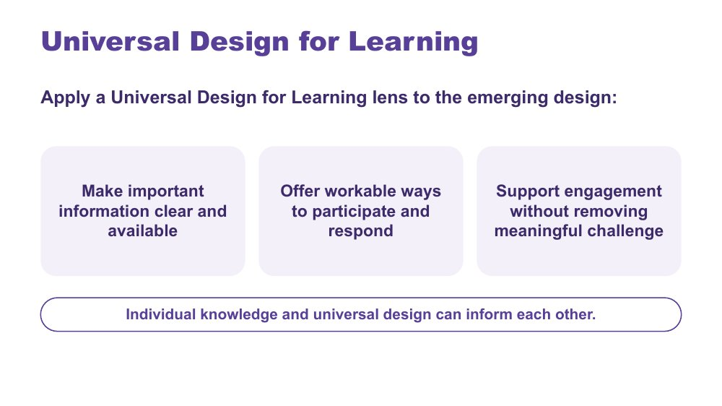 | Universal Design for Learning  SUGGESTED TIME  2 min  MINUTES INTO SESSION  25 - 27

Frame a Universal Design for Learning lens before each person's accessibility check.
WHAT TO DO  - Keep this input to about two minutes.  - Introduce Universal Design for Learning using the three points on the slide.  - Ask participants to hold their emerging design in mind as you go: which point does it already meet?  - Name that individual knowledge and universal design can inform each other. | KEY MESSAGES  - Universal design and individual knowledge can inform each other.  - The presence of a resource does not guarantee access.

SESSION 3 | Designing for Access in the Primary Classroom | SLIDE 10 of 16

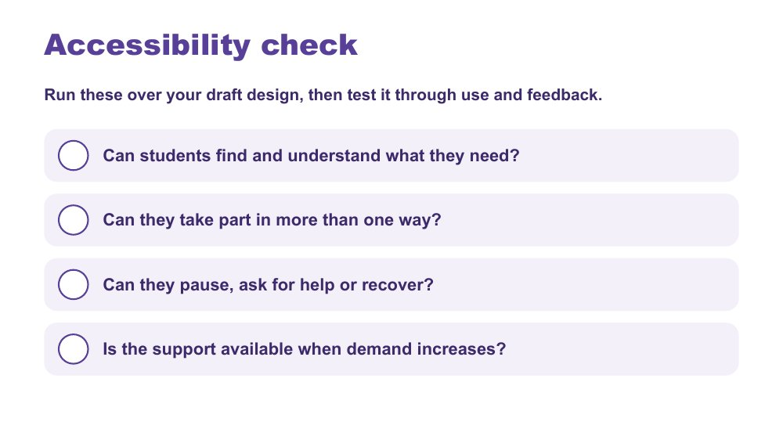 | Accessibility check  SUGGESTED TIME  4 min  MINUTES INTO SESSION  27 - 31  GROUPING  On your own  PARTICIPANT GUIDE  Participant Guide - Accessibility check

Each person tests their draft design against four accessibility questions.
WHAT TO DO  - Ask participants to choose one or two options from the menu, tick them in Options I chose in the Participant Guide, and add them to their brief as a draft design.  - Ask them to run the four questions over their draft design and tick each in the Participant Guide.  - Where the answer is "not yet", ask them to adjust the design before moving on.  - Ask whether participation, help, pause and recovery are available in more than one way.  - Offer a reaction (for example a thumbs up) when people are ready to move on. | KEY MESSAGES  - Accessibility is tested through use and feedback, not assumed from the presence of a resource.

ACTIVITY | Individual check in the Participant Guide on your own · about 4 minutes
Run these over your draft design, then test it through use and feedback.
- Can students find and understand what they need?
- Can they take part in more than one way?
- Can they pause, ask for help or recover?
- Is the support available when demand increases?
- Where the answer is "not yet", adjust the design.

SESSION 3 | Designing for Access in the Primary Classroom | SLIDE 11 of 16

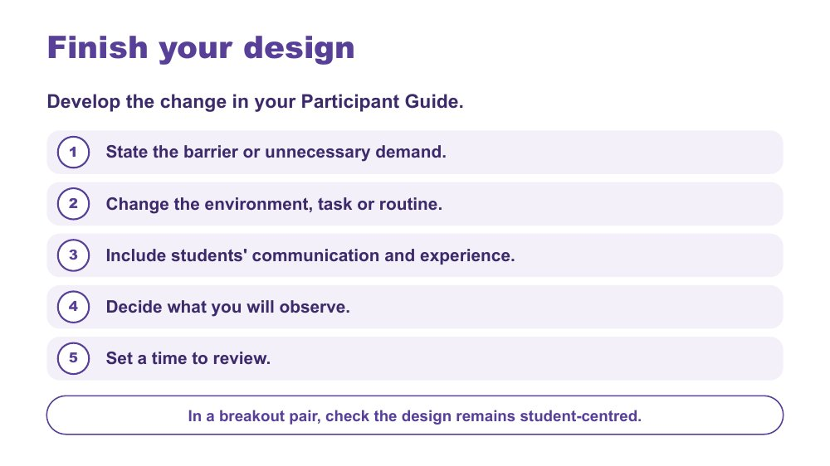 | Finish your design  SUGGESTED TIME  12 min  MINUTES INTO SESSION  31 - 43  GROUPING  On your own, then breakout pairs  PARTICIPANT GUIDE  Participant Guide - My design

Each person develops one practical change to their routine, ready to try and review, then checks it with a breakout partner.
WHAT TO DO  - Ask the producer to paste the five steps and the pair-check question into the chat before breakouts open.  - Give about seven minutes for each person to work through the five steps in the Participant Guide.  - Ask them to name the barrier or demand before choosing a strategy.  - Prompt them to identify what can change in the environment, task, information, timing or routine, and to keep the change small enough to try and observe.  - Producer opens breakout pairs for about five minutes: each person has two minutes to explain their change and hear one question back. Send a one-minute warning.  - Remind pairs to use initials or roles only. Breakout rooms are not recorded.  - Main-room alternative: stay together and invite a three-part chat check (barrier, change, review); read one or two and invite refinements without identifying the context. | KEY MESSAGES  - The measure of success should be access, not compliance.  - The change should be specific, workable and reviewable.

ACTIVITY | Individual design in the Participant Guide, with a breakout-pair check on your own, then breakout pairs · 12 minutes (about 7 minutes design, 5 minutes pair check)
Develop the change in your Participant Guide.
- State the barrier or unnecessary demand.
- Change the environment, task or routine.
- Include students' communication and experience.
- Decide what you will observe.
- Set a time to review.
- In a breakout pair, check the design remains student-centred.
Bring the room back
- Does the change respond to the barrier you named?
- Is it small enough to try?
Close: Keep a one-sentence description of the change and the access question it addresses.

KEEP IN MIND
- Avoid making students' compliance the success measure.
- Some people will prefer not to go to a breakout. Let them stay in the main room with the chat option.

SESSION 3 | Designing for Access in the Primary Classroom | SLIDE 12 of 16

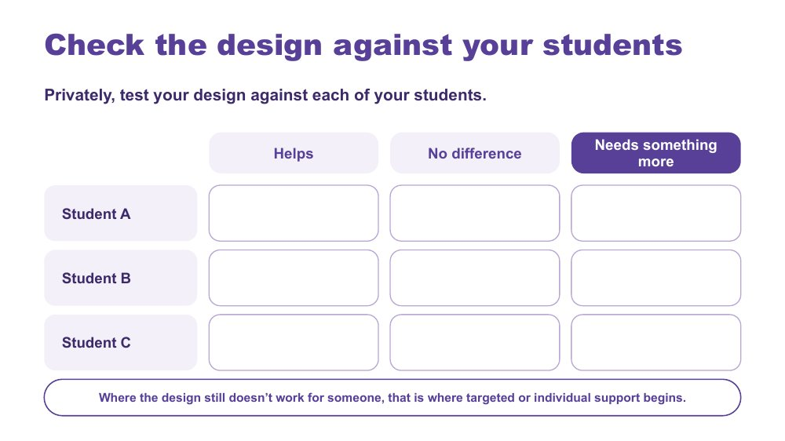 | Check the design against your students  SUGGESTED TIME  5 min  MINUTES INTO SESSION  43 - 48  GROUPING  On your own  PARTICIPANT GUIDE  Participant Guide - My students check

Each person privately tests their design against each of the students they have in mind.
WHAT TO DO  - Welcome people back from breakouts.  - Ask each person to use the My students check in their Participant Guide, privately.  - Ask them to mark each student (Student A, B, C) as Helps, No difference or Needs something more.  - Name that across the group there are many real students being checked against these designs: this is where the broad, mixed picture of autism shows up.  - Invite people to share in the chat only what they choose, for example how many "needs something more" marks their design collected, without describing students.  - Invite one or two examples of "needs something more" to open the continuum discussion. | KEY MESSAGES  - Where the design still doesn't work for someone, that is where targeted or individual support begins.  - One design will work differently for different Autistic students.

ACTIVITY | Private check in the Participant Guide on your own · 5 minutes
Privately, test your design against each of your students.
- List your students as Student A, B and C.
- Mark each: Helps, No difference or Needs something more.
- Share in the chat only what you choose.
Bring the room back
- How many "needs something more" marks did your design collect?
Close: Where it helps, the universal design is doing its job. Where it makes no difference or a student needs something more, that leads into the continuum of support.

KEEP IN MIND
- Keep it private: no names or identifying details, initials or letters only.

Background This keeps individual students in view without building a profile of one child.
Thread Leads straight into the continuum of support.

SESSION 3 | Designing for Access in the Primary Classroom | SLIDE 13 of 16

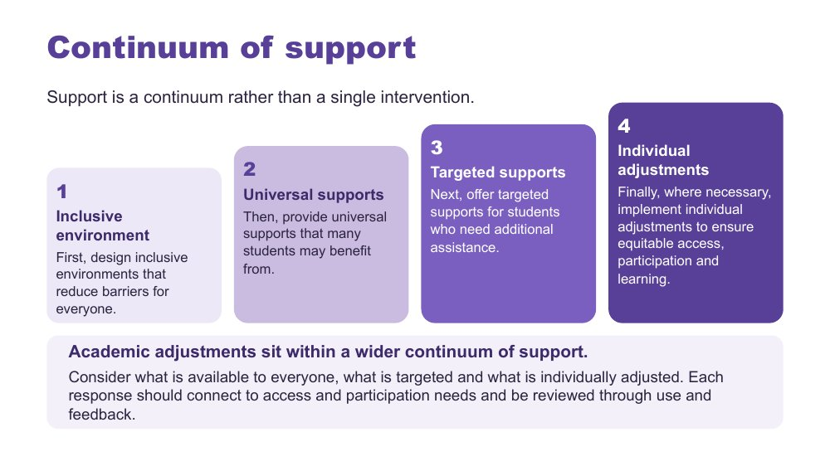 | Continuum of support  SUGGESTED TIME  4 min  MINUTES INTO SESSION  48 - 52

Show what happens when the check shows "needs something more": a continuum from inclusive environment to individual adjustments.
WHAT TO DO  - Open from the "needs something more" examples just shared in the chat.  - Walk the four layers: inclusive environment, universal supports, targeted supports, individual adjustments.  - Use one example per layer from the background below.  - Ask what is available to everyone, what is targeted and what is individually adjusted.  - Connect adjustments to evidence from the day map, consultation and the design process. | KEY MESSAGES  - Support is a continuum rather than a single intervention.  - Academic adjustments respond to access and participation needs.  - Each response should connect to access and participation needs and be reviewed through use and feedback.

KEEP IN MIND
- Do not imply that diagnosis alone determines an adjustment.

Background Inclusive environment: predictable routines, visual schedules, clear expectations, and a classroom culture where different ways of participating are accepted and valued. Universal supports: instructions in verbal, written and visual forms, flexible ways to demonstrate learning, movement breaks, sensory tools available to any student. Targeted supports: a small group receives pre-teaching of key vocabulary, a structured organisation checklist or additional executive functioning supports during independent work. Individual adjustments: a personalised adjustment plan, for example a quieter workspace during assessments, additional processing time, a visual task breakdown and alternative ways to demonstrate learning.

SESSION 3 | Designing for Access in the Primary Classroom | SLIDE 14 of 16

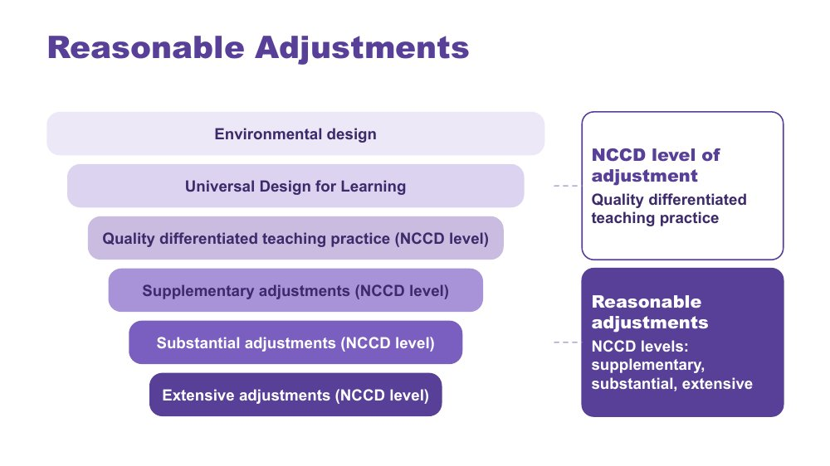 | Reasonable Adjustments  SUGGESTED TIME  2 min  MINUTES INTO SESSION  52 - 54

Place reasonable adjustments and NCCD levels of adjustment within the layers of inclusive design.
WHAT TO DO  - Walk the funnel from environmental design and UDL through quality differentiated teaching practice (an NCCD level of adjustment) to supplementary, substantial and extensive adjustments (the other three NCCD levels of adjustment).  - Give the definition of reasonable adjustments below.  - Distinguish reasonable adjustments (the support actions) from the NCCD (the process for collecting information about them). | KEY MESSAGES  - Adjustments are individualised, strengths based, remove barriers, practical and effective, based on informed decision making, and empowering and enabling.  - Supports and adjustments build student capability, confidence, self-advocacy and independence, not dependence on adults.

YOU MIGHT SAY
Reasonable adjustments are changes or supports that help students access and participate in education in a way that works for them.

KEEP IN MIND
- Do not give legal advice or present the session as a substitute for school or system processes.

Background Adjustments align to the curriculum. Schools consider the needs of the student as well as the impact on staff, other students and available resources. A student is included in the NCCD when they have a disability as defined under the Disability Discrimination Act (DDA), the school has provided reasonable adjustments to address their educational needs, and evidence exists that the adjustments have been provided and monitored. The NCCD helps schools demonstrate compliance with the DSE, monitor the effectiveness of adjustments, ensure students receive appropriate support, and inform planning and resource allocation.

SESSION 3 | Designing for Access in the Primary Classroom | SLIDE 15 of 16

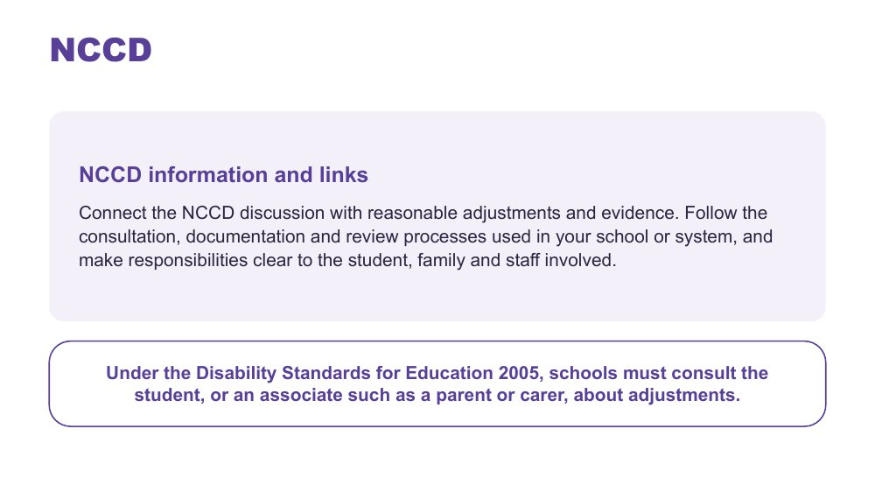 | NCCD  SUGGESTED TIME  2 min  MINUTES INTO SESSION  54 - 56

Direct participants to current official NCCD information and their local processes.
WHAT TO DO  - Ask the producer to paste current official NCCD information into the chat.  - Connect the NCCD discussion with reasonable adjustments and evidence.  - Read the line on the slide: under the Disability Standards for Education 2005, schools must consult the student, or an associate such as a parent or carer, about adjustments.  - Invite participants to follow the consultation, documentation and review processes used in their school or system.  - Encourage them to make responsibilities clear to the student, family and staff involved.  - Direct local procedural questions to the appropriate school or system contact. | KEY MESSAGES  - Use current official NCCD information.  - Follow school and system requirements for local processes.  - Under the Disability Standards for Education 2005, schools must consult the student, or an associate such as a parent or carer, about adjustments.

KEEP IN MIND
- Do not give legal advice or present the session as a substitute for school or system processes.
- Do not imply that diagnosis alone determines an adjustment.

Thread Consultation is developed further in Online Session 4. The NCCD Meetings Tool Kit is listed in the Participant Guide under Connections that continue.

SESSION 3 | Designing for Access in the Primary Classroom | SLIDE 16 of 16

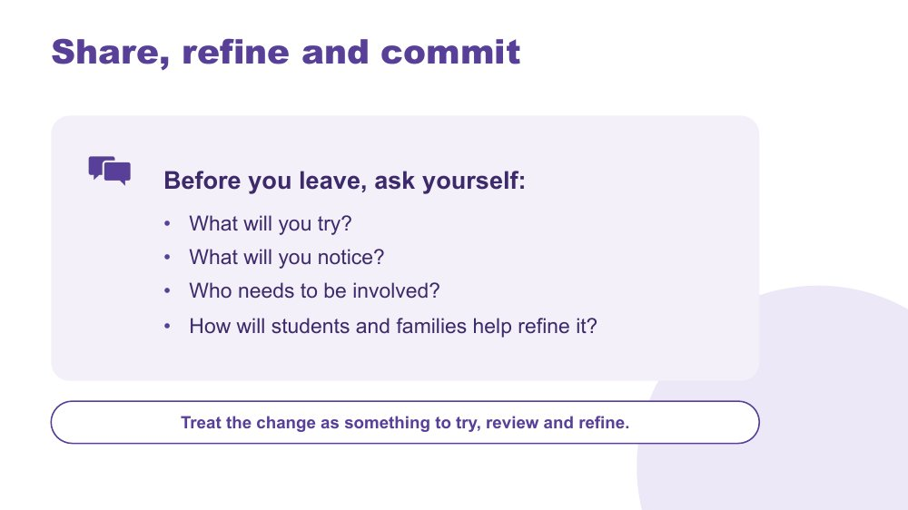 | Share, refine and commit  SUGGESTED TIME  4 min  MINUTES INTO SESSION  56 - 60  GROUPING  On your own  PARTICIPANT GUIDE  Participant Guide - Commit

Refine the design, identify a realistic next step and preview the final session.
WHAT TO DO  - Ask the producer to paste the four questions into the chat.  - Ask participants to write their answers in the Commit section of the Participant Guide: what I will try, what I will notice and who I will involve.  - Invite optional sharing in the chat (roles only), and read one or two aloud.  - Encourage consultation with students, families and relevant school colleagues rather than presenting the design as finished.  - Keep commitments within each person's role; if a trial is not appropriate, a question for consultation is enough.  - Preview Online Session 4 on partnership with families, and ask people to bring their design. | KEY MESSAGES  - A design change is something to try, review and refine.  - Student and family knowledge can refine what educators notice and try.

ACTIVITY | Personal commitment in the Participant Guide, with optional chat share on your own · about 4 minutes
What will you try? What will you notice? Who needs to be involved? How will students and families help refine it?
- Write one thing you will try.
- Write what you will notice.
- Write who you will involve.
Close: Treat the change as something to try, review and refine.

KEEP IN MIND
- Keep any public example anonymised.

Thread Leads into Online Session 4 on home-school relationships and positive partnership.

SESSION  4 | ONLINE · 60 MINUTES · 16 SLIDES  Partnership, Flourishing and Next Steps

SESSION INTENT
Bring student, family and school knowledge together with the student at the centre, examine how power shapes consultation, and close the series with protected time to plan one environment-first classroom action and one purposeful conversation with a family or student, connected to belonging, capacity and joy.
PARTICIPANTS LEAVE WITH
- explain why the student sits at the centre of every partnership
- identify where power sits in home-school meetings and one process change the school could make
- use practical ways to consult students and families, including discussing capacity without blame
- name one strategy to start, one to continue and one to reconsider, each with a way to know it worked
- plan a real conversation with a student's family or the student, to happen within two weeks
- know where continuing learning and community sit beyond the series

RUN SHEET
Minutes in | Segment | Slides | Minutes
0 - 7 | Reconnect: the student at the centre | 1-2 | 7
7 - 21 | Power and student voice | 3-5 | 14
21 - 29 | Consulting well and capacity without blame | 6-8 | 8
29 - 35 | Bridge and flourishing frame | 9-10 | 6
35 - 50 | Action plan and conversation plan | 11-12 | 15
50 - 55 | Final reflection and connections | 13-14 | 5
55 - 60 | Feedback and farewell | 15-16 | 5

PREPARE
☐ Adon video cued with captions; share computer sound tested (slide 5).
☐ Zoom Whiteboard set up with Home, School and Solutions columns, link ready for the chat (slide 4); the chat is the fallback if the whiteboard is not enabled.
☐ Chat text ready to paste: power prompts, action-plan stems, website and feedback links.
☐ Participants reminded to bring their Participant Guide, Session 1 notes and Session 3 commit notes.
☐ Visible timer for the private planning time (slides 9, 11, 12).
☐ Optional breakout pairs ready for the opening-sentence practice (slide 12, 3 to 4 minutes).
☐ Feedback link and QR code confirmed; accessible alternative ready.
☐ Feedback form checked for an online series option (slide 15).
☐ Webinar, deep dive and Community of Practice access information, if supplied.

Producer cues · Session 4
For the producer or co-host. At the start: admit participants, turn on captions, and paste the Participant Guide link and the session title in the chat. For each activity: paste the prompt before rooms open, broadcast a one-minute warning, and close rooms on time.
Slide | Activity | How | Time | Paste in the chat
4 | Power dynamics activity | individual, whole group in the main room | 6 minutes | Where do power imbalances sit in the home-school relationship, and how could you address them?
9 | Bridge to the next family conversation | on your own | 4 minutes | Prepare for one purposeful conversation.
11 | Start · Continue · Reconsider | on your own | 7 minutes | What matters most now, and what is one change you will take forward?
12 | Plan the next conversation | on your own, with optional breakout pairs | 8 minutes (about 4 minutes writing, then an optional 3 to 4 minute pair practice) | Plan one real conversation you will have within two weeks.

SESSION 4 | Partnership, Flourishing and Next Steps | SLIDE 1 of 16

 | Partnership, Flourishing and Next Steps  SUGGESTED TIME  3 min  MINUTES INTO SESSION  0 - 3

Welcome participants back, reconnect with the Session 3 design work and open the final session on partnership.
WHAT TO DO  - Welcome participants back and restate the participation choices: cameras optional; chat, reactions, speaking, private notes or passing all count. People can step away and come back whenever they need to.  - Reconnect since last session: invite people to add a reaction or a short line in the chat if they tried or noticed anything with their Session 3 change. No report needed.  - Pick up the "Who needs to be involved?" question from the Session 3 close (Share, refine and commit).  - If someone missed Session 3, they choose one routine and one small change from the Session 3 options menu (executive functioning supports, predictability, schedules or visual supports) to plan the conversation around.  - Name the shift from what educators can redesign to how home and school can understand and act together.  - Acknowledge that participants may bring both productive and difficult partnership experiences.  - Remind the group that sharing is voluntary and examples stay anonymised: initials or roles only, in the chat and in breakout rooms.  - Let people know this is the last session of the series, and that the second half is protected planning time. | KEY MESSAGES  - Partnership is part of understanding and support, not an additional task after decisions are made.  - The student, family and school may each hold different parts of the picture.

KEEP IN MIND
- If running behind: take one or two Solutions notes only in the power dynamics activity (slide 4) and keep Consultation literacy (slide 6) to one minute. Protect the planning time on slides 11 and 12 and the feedback time on slide 15.

Thread Picks up the Session 3 close ("Who needs to be involved?") and the two or three students participants have kept in mind since Session 1.

SESSION 4 | Partnership, Flourishing and Next Steps | SLIDE 2 of 16

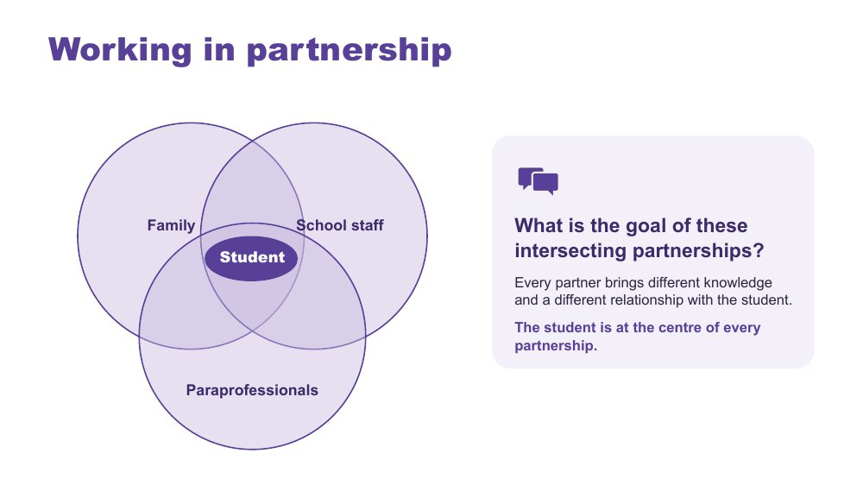 | Working in partnership  SUGGESTED TIME  4 min  MINUTES INTO SESSION  3 - 7  PARTICIPANT GUIDE  Participant Guide - Where partnerships converge

Show where the partnerships around a student intersect, with the student at the centre of every one.
WHAT TO DO  - Introduce the Venn: family, school staff and paraprofessionals, with the student at the centre.  - Explain that every partner brings unique knowledge, expertise and perspectives, and a different relationship with the student and with each other.  - Ask the question on the slide and invite answers in the chat or out loud: What is the goal of these intersecting partnerships?  - Read out one or two chat responses and steer toward the point that the student is at the centre of all partnerships.  - Link back briefly: Autistic flourishing and the lens (Session 1), communication and the school day (Session 2), the design change and continuum of support (Session 3).  - Ask who is missing from the picture and how the student's communication can be included.  - Point participants to Where partnerships converge in the Participant Guide. | KEY MESSAGES  - Positive partnership keeps the student at the centre.  - No single person holds the complete picture.  - Every partner brings different knowledge and a different relationship with the student.

YOU MIGHT SAY
What is the goal of these intersecting partnerships?

KEEP IN MIND
- Use the elements as discussion prompts rather than a complete definition.
- Take one or two chat shares only; keep this moving.

Background With session time limited, this slide is a chance to see where all the partnerships converge and what is needed for success across all of them.
Thread Draws on the lens and Autistic flourishing (Session 1), the primary school day (Session 2) and the Session 3 design change and continuum of support.

SESSION 4 | Partnership, Flourishing and Next Steps | SLIDE 3 of 16

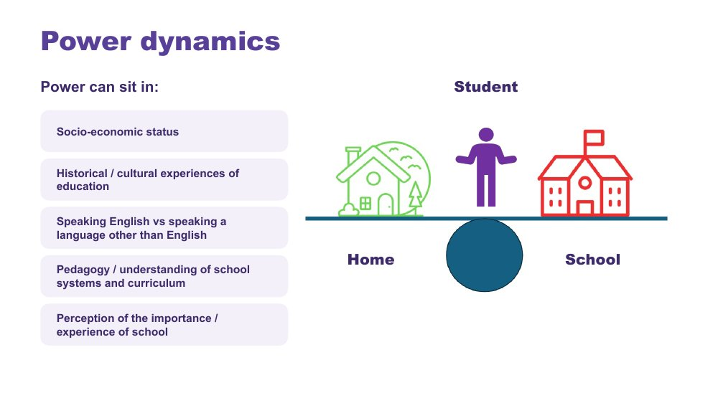 | Power dynamics  SUGGESTED TIME  3 min  MINUTES INTO SESSION  7 - 10

Help participants notice how agendas, language, authority and decision-making shape consultation.
WHAT TO DO  - Introduce the seesaw: school, home and the student.  - Name where power can sit: socio-economic status, historical and cultural experiences of education, speaking English or another language, understanding of school systems and curriculum, and perceptions of the importance of school.  - Ask the power questions below to examine practice, not to blame individual participants. Give a moment of quiet thinking rather than calling for answers.  - Invite educators to identify where school language, timing or process may create a barrier.  - Note that online and phone meetings carry their own power questions too: who can join easily, whose camera is on, and who is doing the talking. | KEY MESSAGES  - Power is present in meeting structures, language and decision pathways.

YOU MIGHT SAY
Who sets the agenda?
Whose knowledge is heard?
Who can make decisions?
Is the student included in a way that works for them?
What could the school change about the process?

KEEP IN MIND
- Avoid describing a family as difficult, disengaged or unrealistic without examining the context and process.

SESSION 4 | Partnership, Flourishing and Next Steps | SLIDE 4 of 16

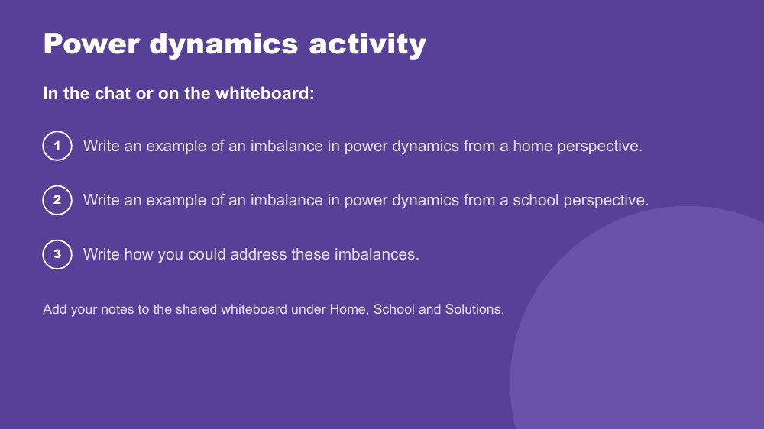 | Power dynamics activity  SUGGESTED TIME  6 min  MINUTES INTO SESSION  10 - 16  GROUPING  Individual, whole group in the main room  PARTICIPANT GUIDE  Participant Guide - Power dynamics

Prompt educators to reflect on perceived and real power imbalances in the home-school relationship.
WHAT TO DO  - Producer: open Zoom Whiteboard with three columns headed Home, School and Solutions, and paste the link and the three prompts into the chat. If Zoom Whiteboard is not enabled, use the chat instead: people start each message with Home, School or Solutions.  - Direct participants to the three instructions on the slide.  - Give a 30-second demo: open the whiteboard, add a note under one column, and show where to find the board again.  - Offer the options: add notes to the whiteboard, type in the chat, or jot privately in the Participant Guide.  - Support the group to look for solutions rather than place blame.  - In the last minute, read out two or three Solutions notes and ask the debrief question that fits best. | KEY MESSAGES  - Power can be structural, historical, cultural, conscious and unconscious.  - Status can be perceived as an imbalanced power dynamic, regardless of intent.

ACTIVITY | Zoom Whiteboard or chat reflection individual, whole group in the main room · 6 minutes
Where do power imbalances sit in the home-school relationship, and how could you address them?
- Write an example of an imbalance in power dynamics from a home perspective.
- Write an example of an imbalance in power dynamics from a school perspective.
- Write how you could address these imbalances.
- Option 1: add your notes to the Zoom Whiteboard under Home, School and Solutions.
- Option 2: type your examples in the chat.
- Option 3: keep your notes private in the Participant Guide.
Bring the room back
- Who sets the agenda?
- Whose knowledge is heard?
- What could the school change about the process?
Close: Ask participants to keep one process change for their conversation plan later in this session.

KEEP IN MIND
- This may be challenging for some participants, who may have found themselves in positions of power or lack of power at different times in their career. Guide individuals to seek solutions and not place blame.
- Whiteboard notes must not identify families, students or staff. Remove anything identifying before the board is saved or shared.

Background Educators are immersed in the culture of education, including a shared understanding of acronyms (e.g. NAPLAN, NCCD, IEP) which families may not be able to access as easily. Some people will purposely and naturally endow teachers with higher status, which can be a cultural or personal attitude. External providers and professionals can also affect the power dynamic between those working with and supporting Autistic students.
Thread The process change chosen here carries into the bridge reflection (slide 9) and the conversation plan (slide 12).

SESSION 4 | Partnership, Flourishing and Next Steps | SLIDE 5 of 16

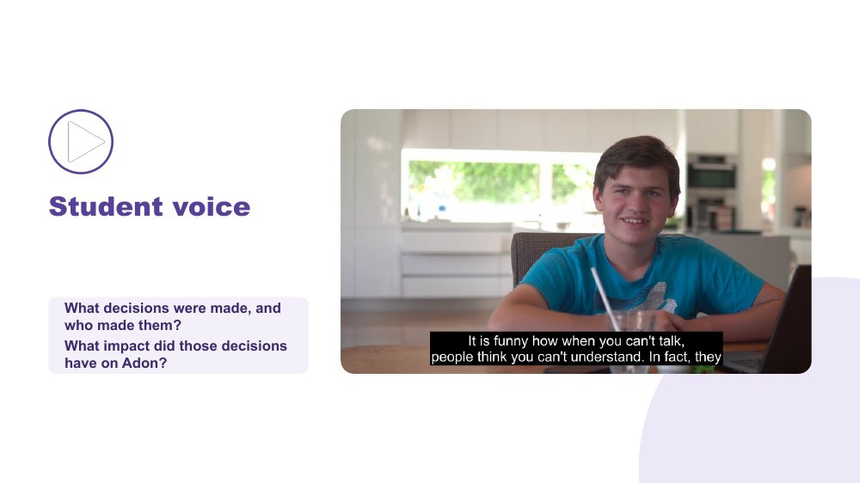 | Student voice  SUGGESTED TIME  5 min  MINUTES INTO SESSION  16 - 21  PARTICIPANT GUIDE  Participant Guide - Student voice

Show what happens when a student is not listened to or consulted.
WHAT TO DO  - Introduce the video as an example of a student who is not listened to nor consulted.  - Ask participants, while watching, to pay attention to what decisions were made and who made them.  - Share the video with computer sound on and captions visible.  - Ask the group: What impact did those decisions have on Adon? Invite answers in the chat or out loud.  - Connect to the students participants have in mind: how are their preferences asked and heard? | KEY MESSAGES  - Students should have a say in decisions about them, at their level and in the way they communicate.  - Even young children can show preferences: choices offered visually, reactions observed and honoured.  - Ask students in a way that works for them: what helps? what's hard? what should teachers know?  - Record their answers in their own words, so the student's view is part of the record.  - This is an early step in building self-advocacy.

YOU MIGHT SAY
While watching, pay attention to what decisions were made and who made them.
What impact did those decisions have on Adon?

KEEP IN MIND
- Check the video plays smoothly over screen share before the session; have the link ready to paste in the chat as a fallback.

SESSION 4 | Partnership, Flourishing and Next Steps | SLIDE 6 of 16

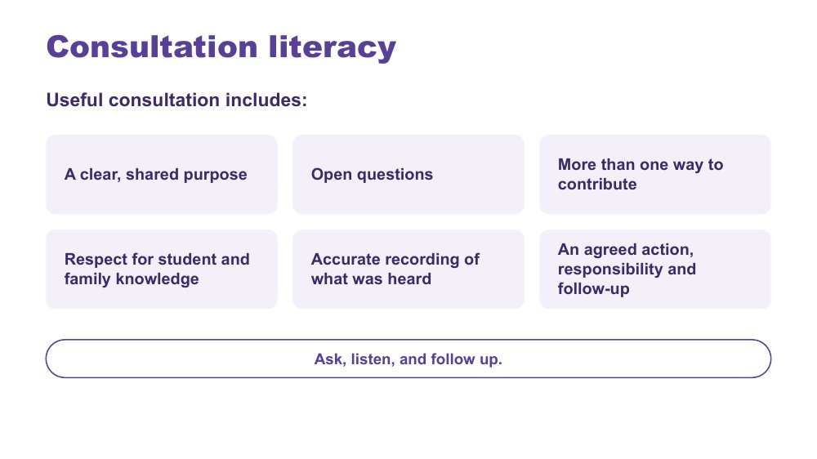 | Consultation literacy  SUGGESTED TIME  2 min  MINUTES INTO SESSION  21 - 23  PARTICIPANT GUIDE  Participant Guide - Consultation checklist

Introduce consultation literacy: asking, listening and following up.
WHAT TO DO  - Walk through what useful consultation includes.  - Frame the list as a check participants can use before and after a meeting.  - Make the point: ask, listen, and follow up. | KEY MESSAGES  - Ask, listen, and follow up.  - Tools should support consultation rather than replace listening and student voice.

SESSION 4 | Partnership, Flourishing and Next Steps | SLIDE 7 of 16

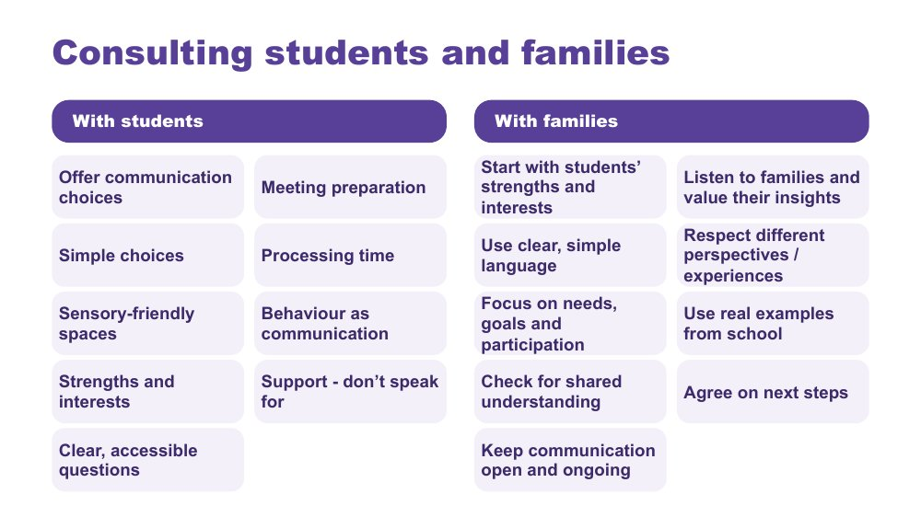 | Consulting students and families  SUGGESTED TIME  3 min  MINUTES INTO SESSION  23 - 26

Give practical ways to consult students and families so every voice can be heard.
WHAT TO DO  - Take the two columns in turn: with students, then with families.  - With students: presume competence, provide communication supports, offer choices, allow time, and act on what students tell us.  - With families: start with the student's strengths, interests and what works well, and listen to families' knowledge of their child without making assumptions.  - Ask participants to pick one practice from each column to try with the students they have in mind, and note it privately. One or two can share in the chat if they like. | KEY MESSAGES  - Listen, adapt, give choices, and make it easy for every student to have a voice.  - Ensure trusted supporters assist communication without replacing the student's voice.  - Use plain language and explain educational terms clearly.  - Focus on the student's needs and goals, not just their diagnosis.  - Recognise that some parents will be neurodivergent themselves.

Background Student consultation: provide multiple communication options (AAC, visuals, writing, drawing, video, symbols); prepare students in advance with questions, agendas and meeting information; use supported decision-making with simple choices and extra processing time; create sensory-friendly environments; recognise that behaviour is communication and can indicate preferences; build on strengths, interests and preferences; use accessible, strengths-based questions. Family consultation: be respectful of different cultures, experiences and family perspectives; use real examples from school to discuss supports and adjustments; check everyone has the same understanding; agree clear next steps and how progress will be reviewed; keep communication open and ongoing.
Thread Picks up the consultation, documentation and review processes named alongside NCCD in Session 3.

SESSION 4 | Partnership, Flourishing and Next Steps | SLIDE 8 of 16

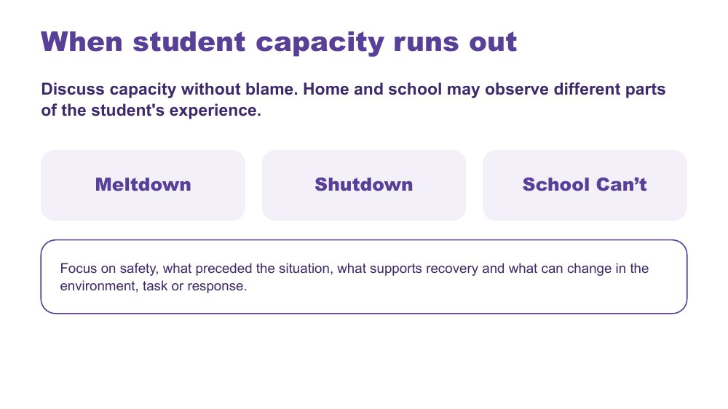 | When student capacity runs out  SUGGESTED TIME  3 min  MINUTES INTO SESSION  26 - 29

Introduce meltdown, shutdown and School Can't within partnership discussion, without blame.
WHAT TO DO  - Let people know this slide touches on distress, and that they can step away or turn off their camera if they need to.  - Introduce the three terms without presenting them as wilful behaviour.  - Connect discussion to accumulated demands, what may not be visible, and what home and school can learn from each other.  - Ask what information, listening and environmental change would help the team respond more safely and usefully.  - Point to the focus line: safety, what preceded the situation, what supports recovery and what can change in the environment, task or response. | KEY MESSAGES  - Capacity should be discussed without blame.  - Home and school may observe different parts of the student's experience.  - Use non-blaming language and the safety guidance for this series.

KEEP IN MIND
- Do not frame meltdown, shutdown or School Can't as wilful misbehaviour or a failure of parenting.
- Do not offer clinical, diagnostic, legal or crisis guidance beyond the material.
- Do not invite personal crisis stories in the chat. If something concerning is posted, follow up privately after the session.

Thread Builds on capacity and accumulated demands across the primary school day from Sessions 1 and 2.

SESSION 4 | Partnership, Flourishing and Next Steps | SLIDE 9 of 16

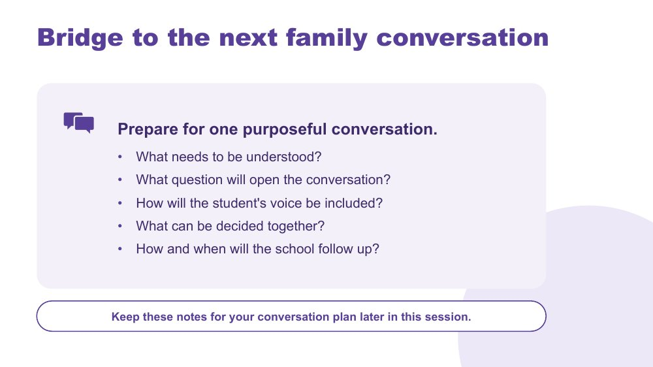 | Bridge to the next family conversation  SUGGESTED TIME  4 min  MINUTES INTO SESSION  29 - 33  GROUPING  On your own  PARTICIPANT GUIDE  Participant Guide - Bridge to the next family conversation

Identify the question and shared purpose participants will take into the conversation plan later in this session.
WHAT TO DO  - Ask participants to return to the students they have in mind and their Session 3 design change.  - Invite them to work through the prompts on the slide privately, in the Participant Guide or their own notes. Cameras can go off.  - Keep the focus on preparation rather than scripting what the family should say.  - Ask participants to carry one process change from the power reflection into the plan.  - Let people know the notes will be used again in about 10 minutes. | KEY MESSAGES  - Prepare for one purposeful conversation.

YOU MIGHT SAY
Keep these notes for your conversation plan later in this session.

ACTIVITY | Private bridge reflection on your own · 4 minutes
Prepare for one purposeful conversation.
- What needs to be understood?
- What question will open the conversation?
- How will the student's voice be included?
- What can be decided together?
- How and when will the school follow up?
Close: Keep these notes open for the conversation plan (slide 12).

Thread Connects to the Session 3 close ("Who needs to be involved?") and the conversation plan on slide 12.

SESSION 4 | Partnership, Flourishing and Next Steps | SLIDE 10 of 16

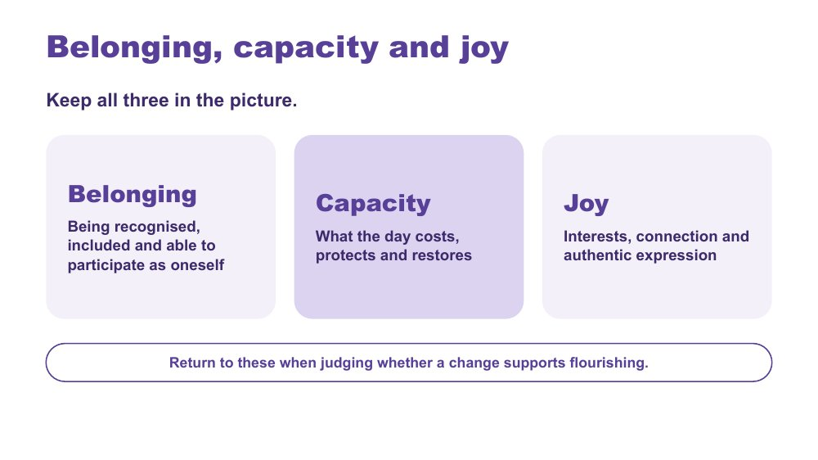 | Belonging, capacity and joy  SUGGESTED TIME  2 min  MINUTES INTO SESSION  33 - 35

Bring together the series lens, classroom design and partnership through belonging, capacity and joy.
WHAT TO DO  - Present belonging, capacity and joy together, as connected ideas.  - Briefly link the series' three practical strands: a neurodiversity-affirming lens that begins with the person; a more accessible classroom shaped by student experience; positive partnership that brings student, family and school knowledge together.  - Invite participants to notice whether their design change supports belonging or joy as well as reducing a barrier.  - Point to the last line on the slide: return to these three when judging whether a change supports flourishing. | KEY MESSAGES  - Belonging, capacity and joy belong alongside access and participation.  - Classroom design and partnership should stay connected to each student's whole experience.

YOU MIGHT SAY
Belonging, capacity and joy run through all three.

KEEP IN MIND
- Avoid presenting academic performance, quiet compliance or conventional independence as the only evidence of flourishing.

Thread Capacity picks up Session 2's thinking about what the school day costs and what lightens it; the whole frame is the test for the Session 3 design change and today's partnership planning.

SESSION 4 | Partnership, Flourishing and Next Steps | SLIDE 11 of 16

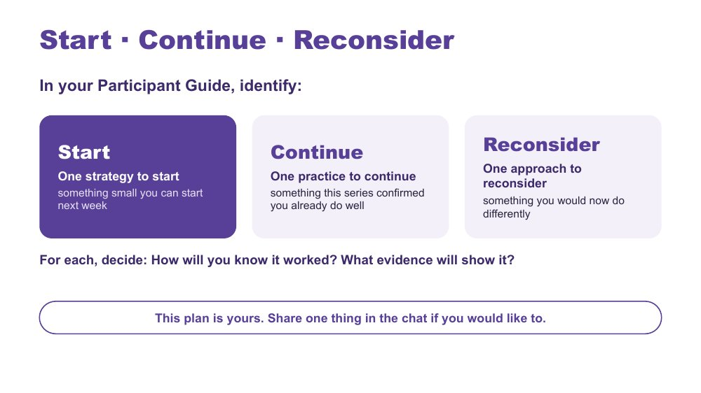 | Start · Continue · Reconsider  SUGGESTED TIME  7 min  MINUTES INTO SESSION  35 - 42  GROUPING  On your own  PARTICIPANT GUIDE  Participant Guide - Start · Continue · Reconsider

Turn the series into one specific, environment-first classroom action, alongside a practice to keep and one to rethink.
WHAT TO DO  - Ask participants to have their Session 3 notes (Share, refine and commit: what will you try?) in front of them.  - Ask what matters most now, rather than for a summary of every topic.  - Suggest their Start can be that same Session 3 change, now with how they will know it worked.  - Producer: paste the stems into the chat: I will... / The barrier or demand I am addressing is... / I will notice... / I need to consult... / I will review this on...  - Check that each Start sits within the participant's influence and does not require a student to appear less Autistic.  - Encourage participants to include when they will consult the student, family or team.  - In the last minute, invite anyone who would like to share one thing in the chat. Read out one or two. | KEY MESSAGES  - Use access, participation or experience as the measure, not outward compliance.  - Choose one insight, question or design opportunity that is specific and small enough to start.

ACTIVITY | Individual action planning on your own · 7 minutes
What matters most now, and what is one change you will take forward?
- In your Participant Guide, identify one strategy to start: something small you can start next week.
- Identify one practice to continue: something this series confirmed you already do well.
- Identify one approach to reconsider: something you would now do differently.
- For each, decide: How will you know it worked? What evidence will show it?
- If time allows, note beside your Start the barrier or demand it addresses, who to consult and when to review it.
- This plan is yours. Share one thing in the chat if you would like to.
Close: Ask participants to keep the action small, testable and open to revision.

KEEP IN MIND
- Do not let 'what they will notice' become outward compliance.
- The plan is theirs: sharing in the chat is optional.

Thread Picks up the Session 3 close (Share, refine and commit: what will you try, what will you notice?).

SESSION 4 | Partnership, Flourishing and Next Steps | SLIDE 12 of 16

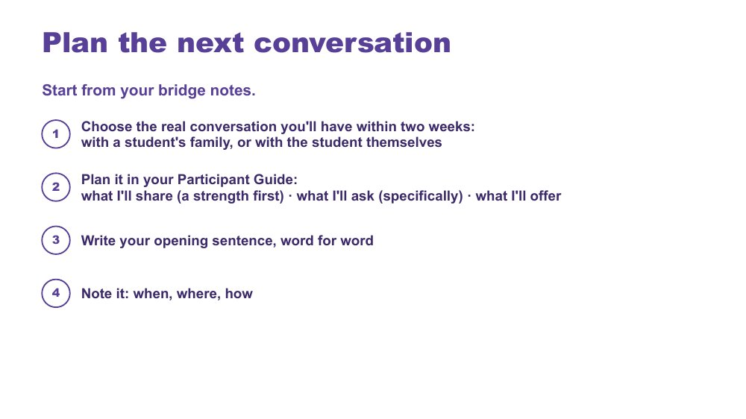 | Plan the next conversation  SUGGESTED TIME  8 min  MINUTES INTO SESSION  42 - 50  GROUPING  On your own, with optional breakout pairs  PARTICIPANT GUIDE  Participant Guide - Plan the next conversation

Prepare one purposeful, power-aware conversation with a student's family or the student themselves, within two weeks.
WHAT TO DO
- Ask participants to open their bridge notes from slide 9.
- Ask them to define the purpose before writing questions or next steps.
- Point back to the bridge prompts: what needs to be understood, how student voice will be included, what can be decided together and how the school will follow up.
- Ask participants to apply the process change they identified during the power-dynamics reflection.
- Give about 4 minutes of private planning time; cameras can go off. Put a visible timer on screen.
- Optional pair practice (3 to 4 minutes, taken from the writing time): producer opens breakout pairs. Each person says their opening sentence aloud and hears one response: does it sound genuinely open? Main-room alternative: type your opening sentence privately in your Participant Guide or notes and read it back to yourself.
- Keep all notes anonymised (initials or roles only) and sharing voluntary.

ACTIVITY | Individual conversation planning on your own, with optional breakout pairs · 8 minutes (about 4 minutes writing, then an optional 3 to 4 minute pair practice)
Plan one real conversation you will have within two weeks.
- Choose the real conversation you'll have within two weeks: with a student's family, or with the student themselves.
- Write the purpose in one sentence: what you need to understand, rather than what you need the family to accept.
- Plan it in your Participant Guide: what I'll share (a strength first), what I'll ask (specifically), what I'll offer.
- Plan how the student's communication and preferences will be included.
- Write your opening sentence, word for word.
- Name one possible shared next step, leaving room for the conversation to change it, and how you will follow up.
- Note it: when, where, how.
- Optional: in a breakout pair, say your opening sentence aloud and hear one response. Or type it privately and read it back.
Close: Invite participants to check that the plan is clear, respectful and genuinely open to family and student knowledge.

KEEP IN MIND
- Avoid scripting the family's response.
- Avoid treating the meeting as a way to secure agreement with a finished school plan.
- Some people will prefer not to rehearse aloud. Let them stay in the main room and type their opening sentence privately.

Thread Starts from the bridge notes (slide 9) and the power-dynamics reflection (slide 4).

SESSION 4 | Partnership, Flourishing and Next Steps | SLIDE 13 of 16

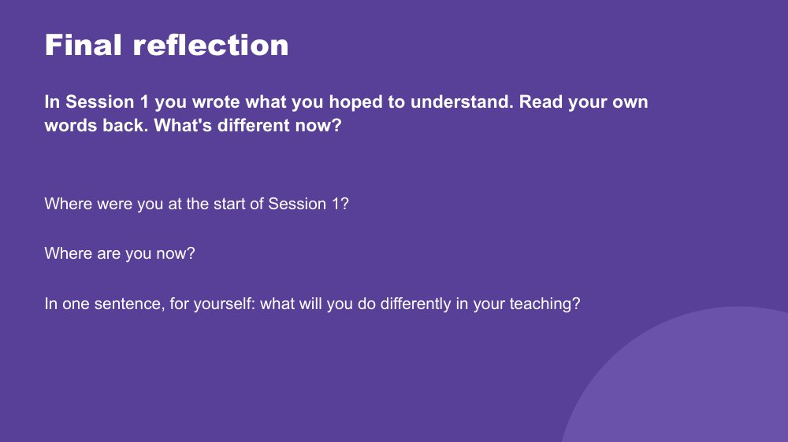 | Final reflection  SUGGESTED TIME  3 min  MINUTES INTO SESSION  50 - 53  PARTICIPANT GUIDE  Participant Guide - Final reflection

Return participants to where they started in Session 1 and name, privately, what has shifted.
WHAT TO DO
- Ask participants to find what they wrote in Session 1 (Think about your students: What are you here for? What would you like to understand better?) and read their own words back.
- Ask: What's different now?
- Give quiet time for the two prompts: Where were you at the start of Session 1? Where are you now?
- Ask each person to answer the last question in one sentence, to themselves.
- Keep it private; no sharing is needed. Cameras can go off.

YOU MIGHT SAY
In one sentence, for yourself: what will you do differently in your teaching?

KEEP IN MIND
- Some people will not have their Session 1 notes. Invite them to think back to what they hoped to understand at the start.

Thread Returns to the Session 1 private reflection (Participant Guide - Think about your students).

SESSION 4 | Partnership, Flourishing and Next Steps | SLIDE 14 of 16

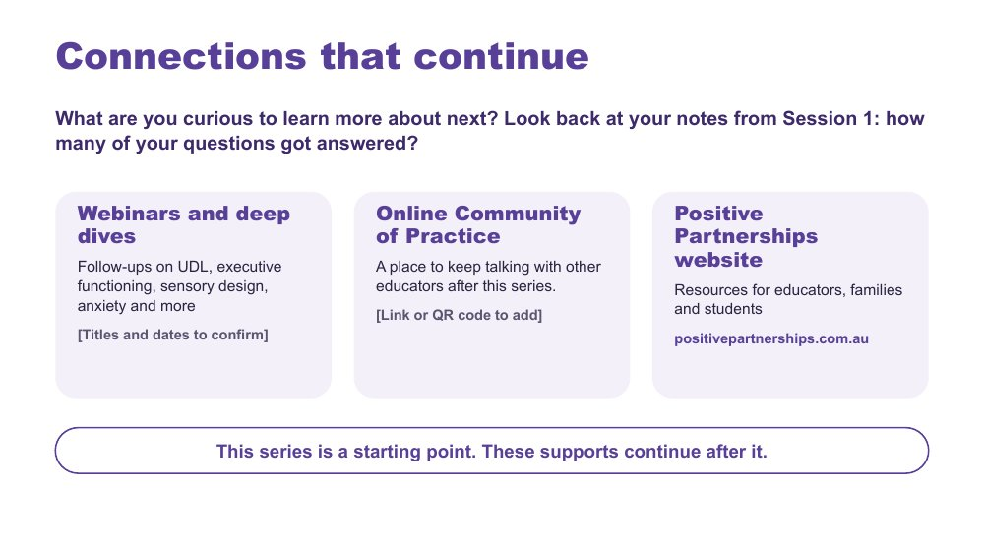 | Connections that continue  SUGGESTED TIME  2 min  MINUTES INTO SESSION  53 - 55  PARTICIPANT GUIDE  Participant Guide - Connections that continue

Introduce continuing professional learning and community pathways.
WHAT TO DO  - Ask: What are you curious to learn more about next? Invite a word or two in the chat.  - Point participants back to their Session 1 notes: how many of their questions got answered?  - Explain how to access each pathway: webinars and deep dives, the Online Community of Practice and the Positive Partnerships website.  - Producer: paste the website and any confirmed links into the chat.  - Keep this brief and practical. | KEY MESSAGES  - The series is one point in continuing professional learning, reflection and partnership.  - Choose the pathway that fits your next question.

YOU MIGHT SAY
This is a starting point. These supports continue after the series.

RESOURCES
- Positive Partnerships website - positivepartnerships.com.au

SESSION 4 | Partnership, Flourishing and Next Steps | SLIDE 15 of 16

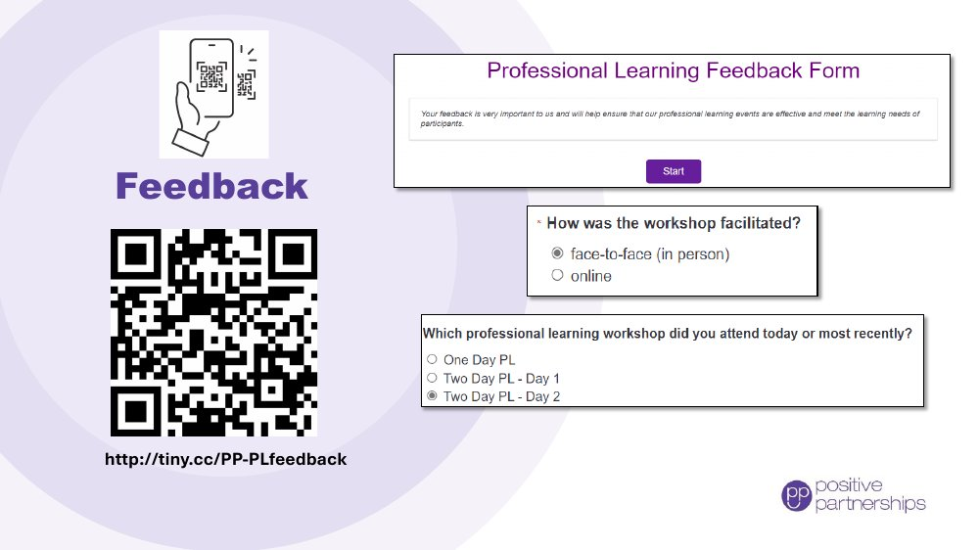 | Feedback  SUGGESTED TIME  4 min  MINUTES INTO SESSION  55 - 59

Collect participant feedback on the online series.
WHAT TO DO
- Explain why feedback is being collected and how it is used.
- Producer: paste the feedback link into the chat; the QR code stays on screen for anyone using a phone.
- Allow protected time for completion before the session ends.
- Let people know they can ask for help in the chat if the form does not open.
- Provide an accessible alternative if the process includes one.

KEEP IN MIND
- Before running, confirm the feedback form has an option for the online series. The form shown on the slide lists face-to-face workshops only.

RESOURCES
- Feedback form - http://tiny.cc/PP-PLfeedback

SESSION 4 | Partnership, Flourishing and Next Steps | SLIDE 16 of 16

 | Good luck on your journey  SUGGESTED TIME  1 min  MINUTES INTO SESSION  59 - 60

Close the series warmly and return participants to student-centred curiosity.
WHAT TO DO  - Thank participants for their attention, questions and professional reflection across the four sessions.  - Invite them to stay curious and keep students at the centre.  - Remind participants to keep their Start · Continue · Reconsider plan and conversation plan.  - State the relevant follow-up and contact arrangements, and leave the room open for a minute for anyone who wants to stay. | KEY MESSAGES  - Stay curious.  - Keep students at the centre.  - Small, informed changes can be reviewed and refined in partnership.

References
Sources named in the slide notes. Background reading for facilitators; participants do not need these.
American Speech-Language-Hearing Association (n.d.). Augmentative and alternative communication [Practice Portal]. asha.org/practice-portal
Brady, N. C., et al. (2016). Communication services and supports for individuals with severe disabilities: Guidance for assessment and intervention. American Journal on Intellectual and Developmental Disabilities, 121(2), 121-138.
Cooper, K., Smith, L. G. E., and Russell, A. (2017). Social identity, self-esteem, and mental health in autism. European Journal of Social Psychology, 47(7), 844-854.
Corden, K., Brewer, R., and Cage, E. (2021). Personal identity after an autism diagnosis: Relationships with self-esteem, mental wellbeing, and diagnostic timing. Frontiers in Psychology, 12, 699335.
Disability Discrimination Act 1992 (Cth).
Disability Standards for Education 2005 (Cth). education.gov.au/disability-standards-education-2005
Human, E. (2015). Tendril theory [comic]. eisforerin.com/2015/08/10/tendril-theory
Hutchins, T. L., et al. (2024). Autism and Developmental Language Impairments. https://doi.org/10.1177/23969415241249944
Milton, D. E. M. (2012). On the ontological status of autism: The double empathy problem. Disability and Society, 27(6), 883-887.
Murray, D., Lesser, M., and Lawson, W. (2005). Attention, monotropism and the diagnostic criteria for autism. Autism, 9(2), 139-156.

